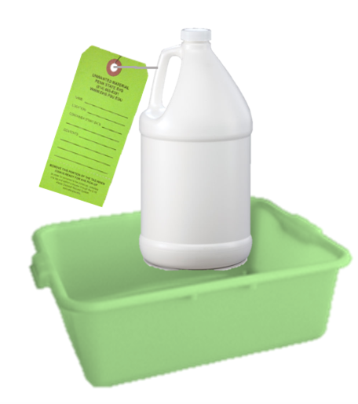

**The satellite accumulation area must be inspected weekly and containers may not exceed 12 months in the accumulation area**

**Containers must have a waste tag completed including full contents and accumulation start date**

**Containers must be closed, with the exceptions of adding, removing, or venting waste**

**Containers must be in good condition and stored in secondary containment**

Chemical Spills in the SAA:

**STOP** the source of the spill

**CONTAIN** the spill

**CLEAN** up all small spills immediately using absorbent materials or universal spill pads

**CONTACT** EHS if replacement containers or secondary containment are needed or to report a sizeable spill

Major Spills:

**EHS:** (814) 865-6391 (M-F 8-5)

**University Police:** (814) 863-1111

**LABORATORY SATELLITE ACCUMULATION AREA**

**LOCATION: ______________________________________________________**

**PI: _____________________________________________________________**

**RESPONSIBLE PERSON: _____________________________________________**

**CONTACT NUMBER: ________________________________________________**