Indoor Air Quality Standard Procedures

- Purpose and Objectives

Investigation of indoor air quality problems can be a complicated task, and often involves a team approach to identify problems as well as immediate and long-term solutions. The EHS approach to indoor air quality investigations references the methods developed by the National Institute for Occupational Safety and Health (NIOSH) in their publication, Guidance for Indoor Air Quality Investigations, as well as recent guidance by other standard-setting agencies such as the American Society of Heating, Refrigerating, and Air-Conditioning Engineers, Inc. (ASHRAE), the U.S. Occupational Safety and Health Administration (OSHA), the American Industrial Hygiene Association, and other standard-setting bodies. In general, the investigative approach seeks to isolate problem sources, often by exclusion, purposing to narrow the range of possible problem causes.

Symptoms arising from poor indoor air quality often mimic those symptoms commonly associated with a cold, flu or allergies. These symptoms may include: upper respiratory irritation, congestion, headaches, nausea, fatigue and itchy or watery eyes. Through occupant interviews, building inspection and air quality testing, Environmental Health and Safety (EHS) and facilities staff are often able to determine the cause of indoor air quality problems.

The objectives of this standard procedure include the following:

- To maintain indoor air quality within acceptable levels according to consensus guidelines,
- To identify any potential health hazards,
- To respond to indoor quality concerns effectively and to make recommendations for improvement,
- To provide information and education to personnel with IAQ concerns on what they can expect,
- To promote ongoing management of indoor air quality.

2. Scope

The Penn State University recognizes the impact that indoor air quality has in the workplace. In an effort to provide the Penn State community with the optimum level of indoor air quality, EHS has developed a standard procedure for responding to indoor air quality concerns.

- Responsibilities

  - Work Unit Administration
University Administrators provide senior management support for implementing the Indoor Air Quality Standard Procedures and ensures that resources are allocated for implementing these procedures.

  - EHS

EHS develops and oversees the implementation of the Indoor Air Quality Standard Procedures by:

3.2.1 Providing oversight, leadership and technical expertise to investigate IAQ-related factors and health concerns, and prospective health concerns.

3.2.2 Communicating the procedure for documenting and responding to IAQ concerns.
Providing a written report to affected parties outlining recommendations and
corrective actions, where appropriate.

3.2.3 Including PSU Occupational Medicine to assist in review or employee medical support, when needed.

3.2.4 Communicating with affected individuals regarding IAQ concerns.

3.2.5 Utilizing industry accepted sampling and evaluation protocols.

3.2.6 Maintaining IAQ records.

3.2.7 Maintaining equipment and instrumentation that is used in indoor air quality
surveys and reviews.

3.3 Safety Officers, Facilities Coordinators and OPP are responsible for:

3.3.1 Responding to IAQ concerns as necessary and collaborating with EHS on
to support assessment activities and prospective recommendations. Please see Appendix A for facility-related guidance.

3.3.2 Coordinating facility/maintenance and construction activities with customers in support of IAQ concerns.

3.3.3 Maintaining building systems that may affect indoor air quality to manufacturer’s recommendations, preventative maintenance schedules and other system support, repairs and modifications.

3.4 Supervisors

Supervisors support the Indoor Air Quality assessments by:

3.4.1 Identifying areas of indoor air quality concern and assisting in all facets of the
Review, as needed, including assisting in EHS evaluation.

3.4.2 Ensuring that all employees who have an indoor air quality concern are supported.

3.4.3 Working with all parties and ensuring EHS recommendations are followed.

3.5 Employee

All PSU employees that have an Indoor Air Quality concern are responsible for:

3.5.1 Initially bringing the concern with their supervisor, facility coordinator, safety officer, and/or EHS. If the concern is an emergency or deemed extremely dangerous, immediately call 911.

3.5.2 Working with EHS, facility personnel and other university representatives during the review.

3.5.3 Following EHS recommendations as outlined in the EHS report.

- Procedures

All University Buildings are designed, built and maintained to provide a comfortable and safe work environment free from environmental and other contamination that may result in diminished indoor air quality. Indoor air quality concerns shall be reported and reviewed following these procedures:

IAQ concerns that pose an immediate threat to personal health or safety shall be reported by calling 911.

  - Initial Symptoms/Factors

OPP/ Area Services or other Penn State Facilities services should be contacted initially to investigate concerns relating to:
- Temperature or humidity problems
- Air movement/drafts from diffusers
- Stale air
- Particulates or dirt coming from air handling systems

OPP/ Area Services, Engineering Services, OPP Divisions, Facilities, or Work Unit Supervisory, or Safety staff may contact EHS for support as necessary.

  - Potential Health & Safety-Related Factors

EHS should be contacted to investigate concerns such as:
- Chemical, gas, exhaust or unusual odors,
- Sickness associated with building occupancy which may include: headaches, nausea, dizziness, upper respiratory irritation, fever, chills and fatigue
- Areas of mold contamination, including any contamination on any component of an air handing system.

EHS will perform an IAQ evaluation using the following elements:

- Discussion and Inspection - Initial assessments may include discussing conditions with occupants, and performing a walk-through inspection (if necessary) of the building or area of concern.

During the site walk-through, building ventilation systems may be evaluated and
potential sources of contamination identified. If the immediate cause or source
cannot be found, testing and further evaluation may be required.

- Testing and Evaluation - Common indoor air quality parameters including
temperature, relative humidity (RH), and carbon dioxide (CO₂) levels are measured. Additional testing may include other environmental contaminants such as carbon monoxide, or specific agents if other potential sources are anticipated or known.

The most commonly cited indoor air quality standards are those established by the American Society of Heating and Air Conditioning Engineers (ASHRAE), and particularly those presented in the standard: Ventilation for Acceptable Indoor Air Quality (ASHRAE 62.1-2010) or current version. The ASHRAE 62.1 standard serves as an industry standard of practice supporting acceptable indoor air quality. The ASHRAE standards are also referenced in the Penn State Office of Physical Plant Design Standards.

Additional air contaminant standards may be referenced, such as those established by the Occupational Safety and Health Administration (Permissible Exposure Limits), the American Conference of Governmental Industrial Hygienists (Threshold Limit Values), or by the U.S. Environmental Protection Agency. The OSHA and ACGIH standards pertain to air contaminants associated with workplace sources. These may or may not pertain to indoor air quality, depending on whether the sources affect other building occupants. The U.S. EPA National Ambient Air Quality Standards (NAAQS) pertain to allowable outdoor contaminant levels associated with many types of industrial sources; however, these standards represent long-term exposure levels, and may serve as a benchmark for indoor air quality.

All building-related factors, equipment, and occupant or maintenance practices that may impact indoor air quality will be considered and/or reviewed and assessed. Refer to Appendix B for more information on factors affecting indoor air quality.

- Recommendations/Report - All sampling results and data are reviewed and analyzed. All findings and recommendations are brought forward and any additional reviews and improvements are discussed. EHS will issue documentation of the review and/or a detailed IAQ report to affected parties.

- Indoor Air Quality Contaminant Sources and Factors
The following contaminant sources and factors may contribute to indoor air quality or indoor environmental quality.

- Building Materials (Newly Installed Components or Finishes)
Building components may be treated with, or formulated with a variety of chemicals and preservatives. These may become a source of indoor air quality problems, particularly if inadequate building ventilation is established. Glues/ adhesives, new carpeting, upholstery, particleboard, furniture, and finishes may off-gas volatile organic compounds (VOC’s) such as formaldehyde or other air contaminants, and contribute to odors, sensory irritation, headaches or other health and comfort-related symptoms to occupants in the indoor environment.
- Carbon Dioxide (CO₂)
Carbon dioxide is a primary component of human respiration, and can be monitored as a surrogate contaminant, reflecting the adequacy of air exchange or ventilation in the building. CO₂ in outside air may commonly range between 300 – 500 parts per million (ppm), as influenced by outdoor CO₂ sources such as local vehicular exhaust, fuel combustion, or other industrial sources. The American Society of Heating, Refrigeration and Air-Conditioning Engineers (ASHRAE) has determined that indoor CO₂ levels should not exceed 700 ppm greater than outdoor levels (300 – 500 ppm), to maintain biological (human) odors at agreeable levels for most occupants.

- Carbon Monoxide (CO)
Carbon monoxide (CO) in the indoor environment may be associated sources such as:
- improperly vented appliances with natural gas or other hydrocarbon fuel sources,
- outdoor vehicular hydrocarbon emissions,
- boilers, heating systems, or other industrial sources.
CO may therefore build-up or accumulate within buildings, where there is inadequate ventilation or fresh-air exchange. With respect to outdoor concentrations, the U.S. Environmental Protection Agency has determined that CO levels should typically not exceed 9 ppm in an 8-hour period, more than once per year, or 35ppm in any 1-hour period more than once per year (National Ambient Air Quality Standards). In most Penn State University locations, outdoor CO levels are not expected to routinely reach the USEPA NAAQS. Detectable CO levels indoors are most often associated with infiltration from outdoors, and indoor levels exceeding these guidelines should be further investigated.

- Other Indoor Contaminant Sources
Indoor contaminant sources may also include:
- Cleaning agents
- Sewer gas from dry floor or sink drain traps
- Appliances not properly maintained or exhausted
- Cosmetics
- Humidification devices not properly maintained
- Smoke or soot from inadequately vented appliances
- Painting supplies, or other source materials or agents

- Other Outdoor Contaminant Sources
Outdoor contaminant sources may also include:
- Exhaust from motor vehicles
- Fumes from construction or renovation activities
- Odors from landscaping materials, pesticides, etc.
- Smoke

- Inadequate Ventilation
Inadequate ventilation occurs when an insufficient amount of fresh outside air is supplied to the interior environment.

- Microbial Contaminants
Microbial Contamination may occur in buildings that are impacted by water leaks, build-up of humidity, and other sources of moisture. Contaminants can also be introduced into buildings from stagnant water in HVAC distribution systems and cooling towers. Prevention of microbiological contamination is accomplished by eliminating standing water and other sources of moisture, and by the proper use of biocides.

- Temperature (°F) and Relative Humidity (%RH)
Relative humidity levels can affect the release rate of many indoor contaminants, their concentrations in the air, and can influence the growth of microbial organisms. Relative Humidity can also have a direct effect on worker comfort. An optimal range for relative humidity is 20 to 60%, depending on season. Relative humidity levels routinely less than 20% may contribute to skin, eye and mucous membrane drying, and levels routinely exceeding 60% may contribute to mold growth.

Temperature and relative humidity levels may have a direct impact on occupant comfort, the release of other contaminants and/or microbial growth, and subsequent occupant symptoms, complaints or visibly deteriorating building materials. The Occupational Safety and Health Administration (OSHA) has reported that ideal indoor temperature for office occupancies may range between 68 – 76F, and that ideal relative humidity levels should range between 20 – 60%. ASHRAE and other standard-setting agencies currently address thermal comfort in terms of these and other factors including: air movement/speed, clothing and temperature differential.

Indoor temperature and humidity share an integral relationship. In general, more moisture may be retained in air at lower temperatures and constant barometric pressure. Below these “dew point” temperatures, water may condense on cold or cool surfaces within the room or building. This condition may contribute to the collection and build-up of airborne dusts and debris that contain fungal spores onto the wetted surfaces, with subsequent mold growth.

Relative humidity levels less than 20% have generally been associated with occupant discomfort associated with drying of eyes, nose, throat, mucous membranes and skin, thus certain minimal level of relative humidity should be maintained.³ Many agencies have historically recommended that relative humidity levels be maintained indoors to less than 60% to reduce condensation or equilibrium moisture vapor pressure at surfaces, and to prevent microbial growth. ASHRAE has recently recommended that RH should not exceed 65% when buildings are properly operating at design conditions with respect to dehumidification.

- Respirable and Ultra-Fine Particulates
Airborne respirable and ultra-fine particulates, associated with copier toners, inks, and paper products are anticipated with high production copying. Depending on the copier manufacturer’s internal controls or products associated with the copier equipment, low level respirable particulate exposures may occur; however, these exposures are substantially less than the corresponding occupational exposure criteria such as the OSHA Permissible Exposure Limit, eight-hour time-weighted average (TWA) of 5 mg/m³, or, the ACGIH Threshold Limit Value-TWA of 3 mg/m³ inhalable mass for carbon particulate (inhalable mass).

Inks and toners may also have very small quantities of metals and/or resinous components; however, these components are anticipated to be at airborne exposure levels significantly less than applicable occupational exposure criteria, and may be associated with individual response (irritant or allergic), at levels less than occupational exposure criteria.

The USEPA NAAQS² for particulate matter with a mass median aerosol particle diameter (MMAD) of 2.5 micron (PM2.5), is 35 micrograms per cubic meter air (ug/m³) as a 24-hour mean, not to be exceeded more than once per year over a 3-year period. Similarly, the PM10 (MMAD 10.0 microns) is 150 ug/m³ (24-hour mean not to be exceeded more than once per year, over 3 years). Though not directly applicable to the indoor environment, these levels provide a basis for understanding public health risk, assuming a long-duration, annual exposure.

ASHRAE standard 62.1-2010 (or current) provides listings including: “Comparison of Regulations and Guidelines Pertinent to Indoor Environments” (Table B1), and “Concentrations of Interest for Selected Volatile Organic Compounds” (Tables B2 and B3). Whether performing screening evaluations, such as this survey, or measuring specific compounds, these published levels may provide a basis to support evaluation efforts.

- Ozone (O3) or Related Oxygen Free Radical Compounds
Ozone is produced via operation of office machines, copiers and electrostatic appliances. Both occupational and public health exposure criteria have been established for ozone. Ozone is attributable to exacerbations of asthma, and to irritant effects on eyes, nose, throat, lung and mucous membrane tissues. Ozone may also accelerate aging of lung tissue and contribute to the degradation of property due to it’s oxidizing effects.

OSHA has established a PEL-TWA for ozone of 0.1 ppm. The ACGIH has established TLV-TWA criteria based on the level of work activity encountered during exposure, ranging from 0.05 ppm during heavy work to 0.2 ppm during light work. The USEPA NAAQS for ozone is 0.12 ppm as a 1-hour exposure not to be exceeded during a year, and otherwise 0.08 ppm as the fourth highest 8-hour daily maximum exposure when averaged over a 3-year period. ASHRAE has listed a 100 ug/m³ (0.1 mg/m³) Concentration of Interest for ozone (a level at which physical and health-related symptoms or effects may occur in the indoor environment).⁵

- Additional References:
- General Duty Clause of the OSH Act of 1970, Section No. 5
- OSHA Permissible Exposure Limits (29 CFR Part 1910.1000, Tables Z1 – Z3) found at https://www.osha.gov/pls/oshaweb/owadisp.show_document?p_table=STANDARDS&p_id=10147
- OSHA Annotated Air Contaminant Standards List found at:
https://www.osha.gov/dsg/annotated-pels/tablez-1.html
- U.S. Environmental Protection Agency – Indoor Air Quality website found at http://www.epa.gov/iaq/

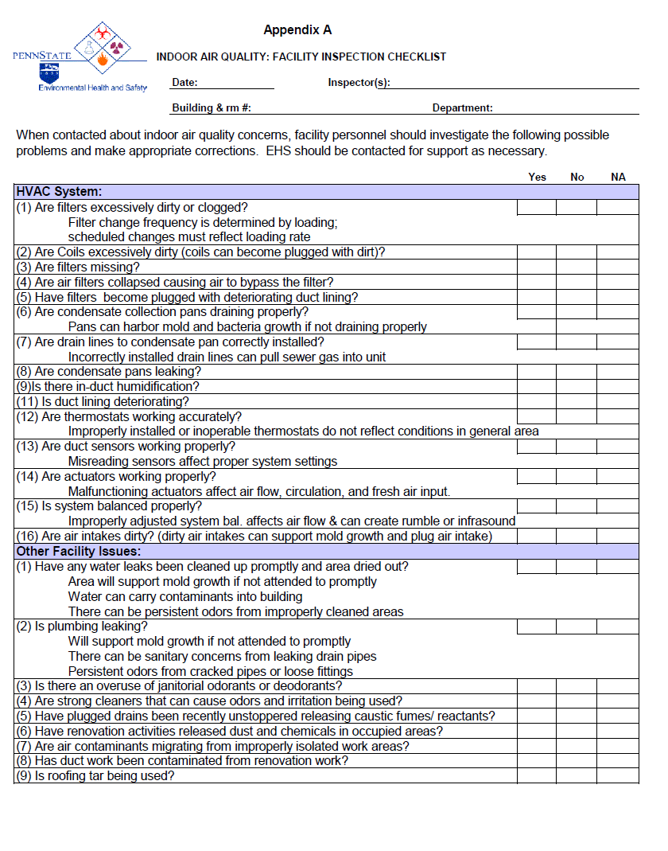

Appendix B

Indoor Air Quality
Introduction

Most people in the United States spend 90+% of our time in indoor environments, including vehicles, work and home environments. We expect the air to be reasonably comfortable, which usually means reasonable temperature, humidity, avoidance of drafts or stuffiness, and absence of unpleasant odors or irritation.

Factors Affecting Indoor Air Quality

Temperature:
A comfortable temperature is usually between 68-78 degrees F. This comfort zone varies by season and relative humidity when we are usually acclimated to cooler temperatures in winter and warmer temperatures in summer. An individual's comfort usually depends on:
- Amount of work performed
- Clothing required
- Evaporative Losses
- Convection: Location near air vents, air conditioners
- Radiant Heat: If near window this may be significant at different times of the day

Relative Humidity:

The effects of relative humidity on comfort are related to the air temperature. Optimum humidity is usually between 30-50 percent. Levels higher than 60% relative humidity will promote mold spore growth and increases in dust mites. Levels of relative humidity below 20% cause skin and mucous membrane dryness, and may result in increased susceptibility to viral illness transmission. Humidity levels generally increase during the summer months. Complaints of dry air, more frequent during winter months, can be alleviated by supplementary humidification and lowering the office temperature to University recommended values during the winter months. If humidifiers are used, following the manufacturer’s recommendations for maintenance and conditioning of the water with bactericide is important to prevent the water from becoming a reservoir for bacteria.

Ventilation:

Ventilation refers to the process of supplying and removing air by natural or mechanical means to and from any space. Such air may or may not be conditioned.

Natural ventilation is the movement of outdoor air into a space through provided openings, such as windows and doors, though non-powered ventilators or by natural infiltration into a building. A ventilation system is usually a powered system that moves air throughout the occupied space. The system may include heating and cooling of the air. Supply air is air delivered to the space and used for ventilation. Exhaust air is air removed from a space and not reused. Where air contaminant or odor control is necessary, local exhaust ventilation is used to remove contaminants from the space.
Most building ventilation systems use a combination of re-circulated air and make-up air to provide ventilation within the occupied space. Re-circulated air is air removed from the space and intended for reuse as supply air. Make-up air is outdoor air supplied to replace exhausted air to supply fresh air needs of the occupants. The mix of fresh air and make-up air is usually controlled by the system depending on outside air temperatures. The systems are set to provide no less than acceptable fresh air volumes and more fresh air when outside conditions allow. Most ventilation systems provide filtration of the air to remove dust and particulates from the air stream before it is delivered to the occupants.

Adequate Ventilation is defined by the American Society for Heating, Refrigeration, Air Conditioning Engineers (ASHRAE) as 20 cubic feet per minute (CFM) per person, per the ASHRAE Ventilation for Acceptable Indoor Air Quality guidelines. This is a recommended guideline which is in common practice at Penn State, but does not have statutory standing except where it has been incorporated into, for example, local or state building codes.

Carbon dioxide (CO₂) levels are used as an indicator of the amount of fresh air being supplied to the occupants of an area. CO₂ is a normal product of respiration, which occurs naturally in the outdoor air at 350 – 500 parts per million (PPM). The general recommendation from the National Institute for Occupational Safety and Health (NIOSH) and ASHRAE is to provide enough fresh air to the indoor environment, to ensure that CO₂ levels do not exceed 700 ppm above outdoor air concentrations. Levels maintained below this concentration in the indoor environment are generally associated with few complaints of stuffiness or odors by occupants. Indoor occupant complaints increase when CO₂ levels exceed these concentrations. Levels below 5000 ppm are considered acceptable by OSHA and are not considered a health hazard; however, increased indoor CO₂ levels are associated with reduced oxygen concentration, and can not only lead to the build-up of odors, but to symptoms of lethargy and other occupant discomfort.

Air Contaminants:

Odors – Odorants may not be toxic, per se, but may cause anxiety or the perception of poor indoor air quality. They are a major cause for complaints in indoor environments. Odors may also indicate contaminated air being circulated either from outdoors or generated within the building and distributed throughout the building. Many building maintenance activities are potential sources of volatile organic compounds (VOC's). The emissions from sources such as waxed floors generally recede with time, but may continue for days after a single application. Consumer products may also contribute to indoor VOC concentrations and include potpourri, perfumes and air fresheners.

Particulate matter is also considered an air contaminant in the indoor environment, and may include: soils, dust, pollen, mold spores and bacteria. Dust from outdoor activity or internally generated can degrade the indoor environment. Dust levels considered appropriate for a shop environment typically are not acceptable for an office environment. Biological particulates including mold, bacteria and pollen are found at varying levels seasonally and even daily in the outdoor air. The levels of these biological particulates are typically lower inside buildings. Molds and mold spores may be associated with sources ranging from indoor plants to flooding and water infiltration to buildings and soaked building materials. Uncontrolled mold growth in the indoor environment degrades indoor air quality and building materials, and should be controlled. Most minor mold growth in the indoor environment though is not associated with significant health effects; however, allergens associated with mold may cause allergenic or flu-like symptoms in sensitive individuals.

Smoke – Eliminating smoking in most areas of University Buildings has been one of the most important steps the University has taken to improve indoor air quality. This step has eliminated exposure to toxic air contaminants and eliminated a major contribution to objectionable odor within buildings.

Maintaining Acceptable Indoor Air Quality

Maintaining acceptable indoor air quality is accomplished by:

- Monitoring and maintaining the operation of HVAC equipment, and repairing and adjusting equipment as required to maintain proper air flow within occupied spaces.
- Routine maintenance of equipment including scheduled filter changes to keep the equipment running and providing clean air. The Office of Physical Plant performs regularly scheduled maintenance of HVAC equipment.

- Identification of external intake air contamination and relocation of equipment/source so that it will not impact the IAQ. For example, a hot asphalt roofing ‘kettle’ located near a building air intake.
- Identification of internal sources of air contamination and elimination of the source or substitution of materials that do not generate problems. Contaminant sources such as copier effluents may build-up in office environments, if the exhaust flow is inadequate.

- Good housekeeping in general will help maintain indoor air quality by controlling odors and dust within the occupied space.
- Use of cleaning and maintenance materials that do not emit objectionable odors or vapor into the indoor environment.

- Use of low emission building materials, carpeting and furniture will help maintain low levels of VOCs, supporting acceptable air quality.

- Isolating areas during construction/ renovation activities, and providing enhanced ventilation to prevent dust and odors from impacting occupants within the building.

EHS responds to requests to evaluate indoor air quality issues. In addition to notifying the Work Unit Maintenance Supervisor (Commonwealth Campuses), and/or University Park Facility Coordinator and/or Safety Officer, indoor air quality concerns should be brought to the attention of EHS when they arise. EHS will monitor conditions and make recommendation if required to bring the occupied area(s) within recommended guidelines.

ASHRAE. 2010. Ventilation for Acceptable Indoor Air Quality. ANSI/ASHRAE Standard 62.1-2010, American Society of Heating, Refrigeration and Air-Conditioning Engineers. Atlanta, GA, Appendix C, pp. 37-38
USEPA. 2008. Code of Federal Regulations, Title 40, Part 50. National Ambient Air Quality Standards
OSHA. 2003. OSHA Policy on Indoor Air Quality: Office Temperature/Humidity and Environmental Tobacco Smoke. USDOL/OSHA, Washington DC. https://www.osha.gov/pls/oshaweb/owadisp.show_document?p_table=INTERPRETATIONS&p_id=24602
Ibid ASHRAE. 2010. Section 5.9.1, p.7
ASHRAE. ANSI/ASHRAE Standard 62.1-2010- Ventilation for Acceptable Indoor Air Quality, American Society of Heating, Refrigerating and Air-Conditioning Engineers. 2010, Tables B1-B3, pp. 27-36
OSHA. Occupational Safety and Health Administration Permissible Exposure Limits, 29 CFR 1910.1000 & Z-Tables.
ACGIH. 2011 TLV’s and BEI’s Based on the Documentation of the Threshold Limit Values for Chemical Substances and Physical Agents & Biological Exposure Indices. ACGIH. 2011.

