AED Sign Guidance for Non-University Park Locations
An adequate number of signs must be strategically located within the building to identify AED unit location(s). Standardized sign graphics, colors and format are necessary for universal visual recognition.

Examples of standard sign types and locations are listed below.
A three dimensional wall sign above each AED unit is mandatory (Type 1)
Wall mounted signs with directional arrows (Type 2 and 3) can be flush mounted to the wall face or perpendicular to the wall and double sided using a bracket.
Note that in many instances a customized description of the AED location will need to be provided (type 2).

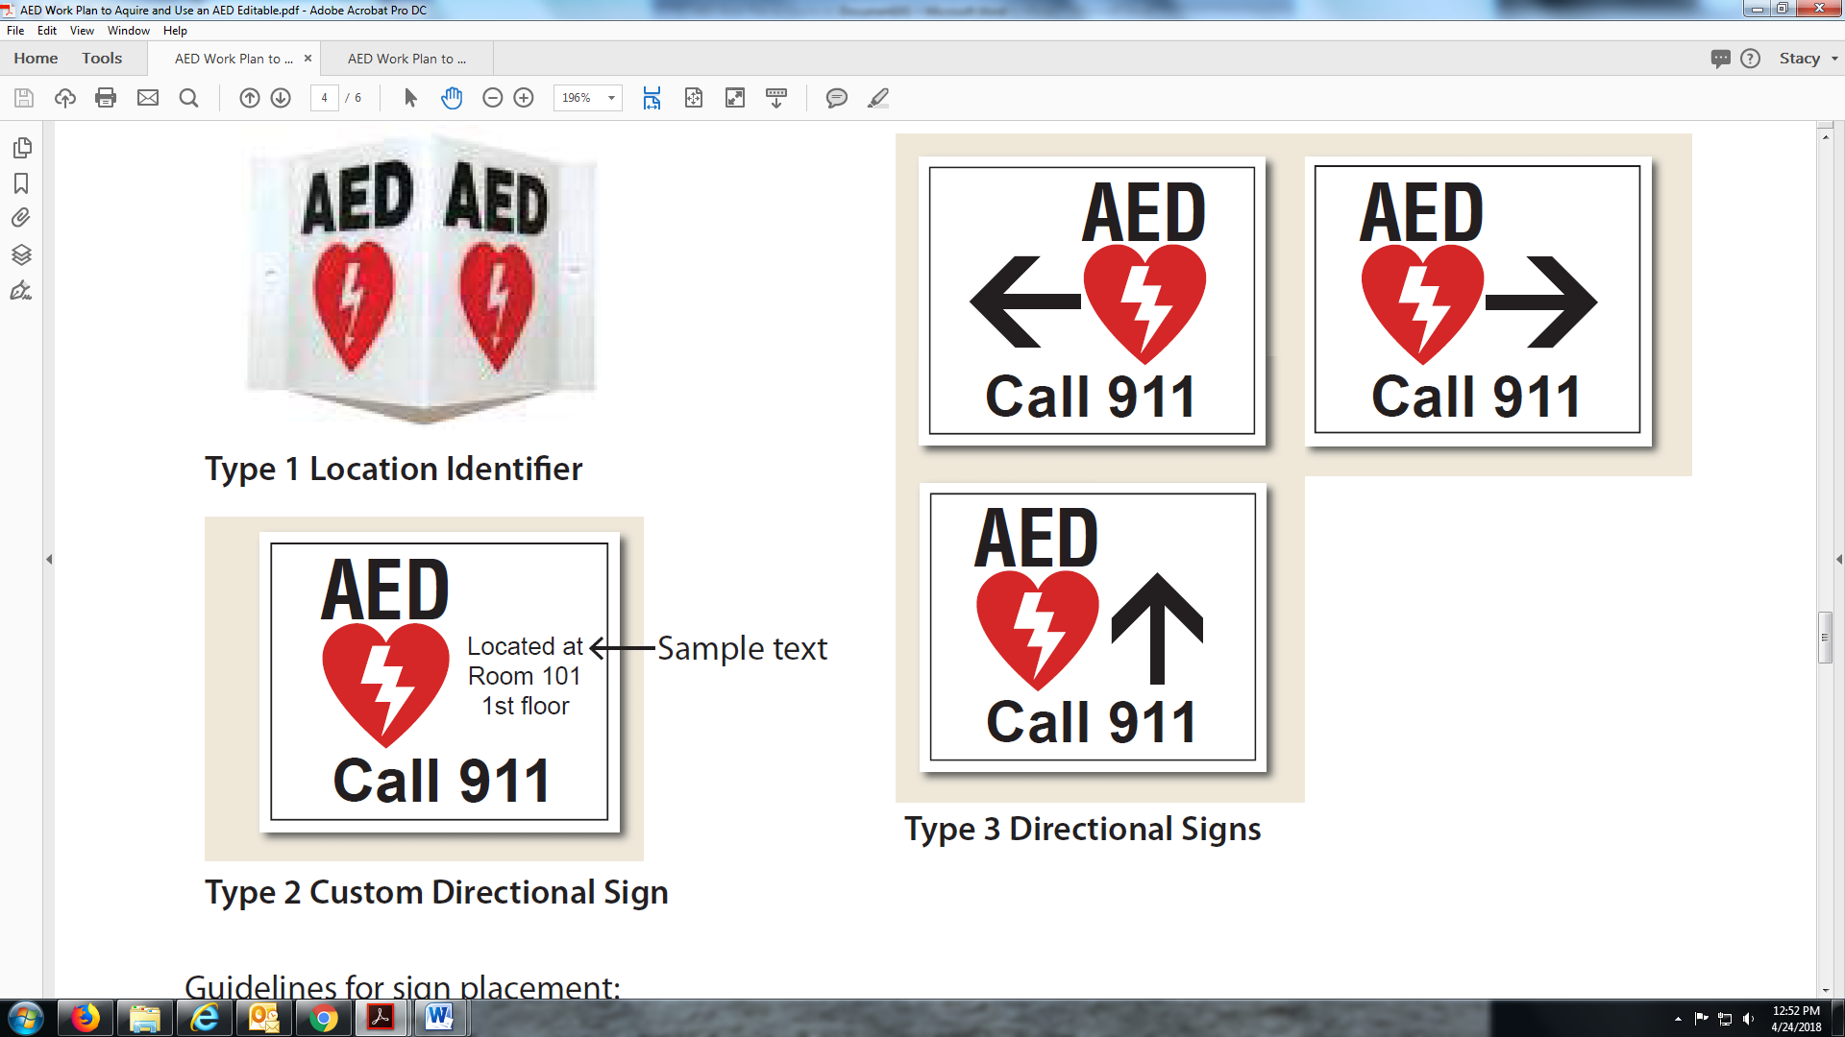

Guidelines for sign placement:
Near exit routes, stairs, elevators
Near other types of emergency devices
Near areas where large numbers congregate
Note that AED signs will be mounted above eye level
The purchase and installation of any AED signage is the responsibility of the work unit.

