AED Monthly Inspection Form with Instructions
This form has been developed for AED owners at non-University Park locations.

At the beginning of each calendar year, a new unique form should be created for each AED. There are 12 lines on the form, one for each month of the year.

- Campus/Work Unit – This can be a campus location, or a Penn State location that is not associated with a campus location. For example, “Fayette Campus” or “Erie - Grape Research”.

- AED Building/Location – If the building only has one AED listing just the building name is acceptable, however if the building has more than one AED the location of the AED must be specified.

- Make/Model/Serial Number – The Make for all PSU AEDs at this time is Philips. Only Police Services have been authorized to use the Philips model FR3, so if you are not Police, your AED model is an OnSite. The serial number is located on the back of the unit as shown below. This information is also on file with EHS.
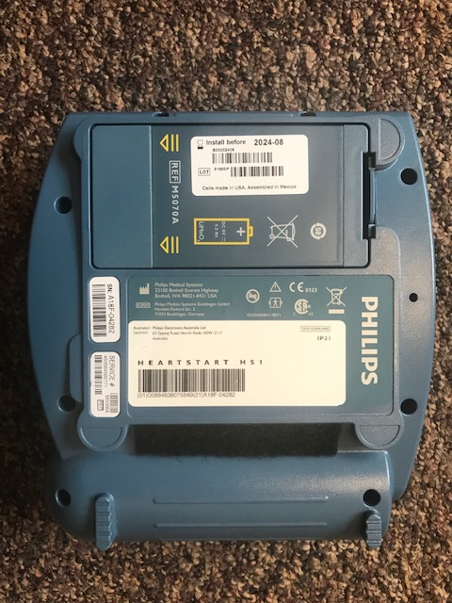
Here is the serial number

- Date – The AED Program requires that the AEDs be inspected monthly.

- Inspector Initials – The initials of the person doing the inspection should go here.

- Unit Intact? - Inspect the overall condition of the AED and case. Make sure that it is not cracked, is otherwise in good condition and is ready for use. Check that the connector sockets on the AED are free of cracks or other damage that would prevent the it from functioning properly. Note that the connectors on the pads cannot be checked as they are sealed inside the protective bag. They should be checked any time pads are used. DO NOT pull the green tab marked “PULL” unless you are about to use the AED on a patient. The conductive gel on the pads will dry out.

- Battery Functioning? – The green ready light signals that the AED is in operating condition. If the green light isn’t blinking, then first remove and reinsert the battery. If this doesn’t remedy the problem, insert a new battery. If the unit continues to be inoperable take it out of service, make appropriate notifications to the building occupants and EHS immediately. Note that the AED will start to beep every few seconds when the battery is beginning to die. It is a good idea to write the installation date on the battery and when it has reached an installation date of 4 years, go ahead and request a replacement battery.

- Pad Expiration Date – Note the expiration date on the pads installed in the unit. One month prior to their expiration notify your AED Work Unit Coordinator that you need replacements. Note – If you have a set of spare or pediatric pads, include them on the form as well, either in the comments section or at the bottom of the page in the notes.

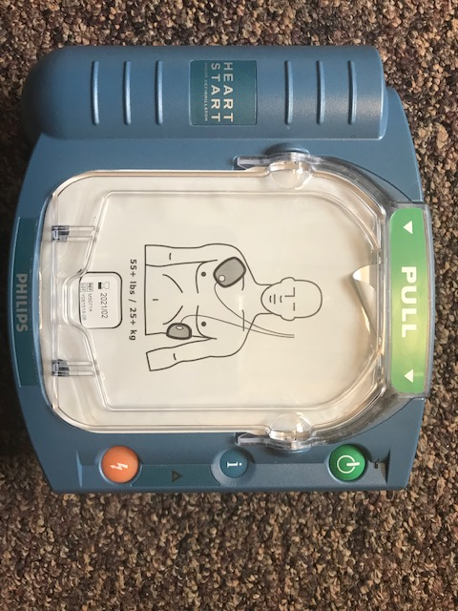
Here is the expiration date for the pads

- Rapid Response Kit Present & Intact? – Is the rapid response kit located with the AED and is it intact with original supplies (including but not necessarily limited to scissors, gloves, and a mask)? If not, notify your AED Work Unit Coordinator immediately so that a replacement can be ordered.
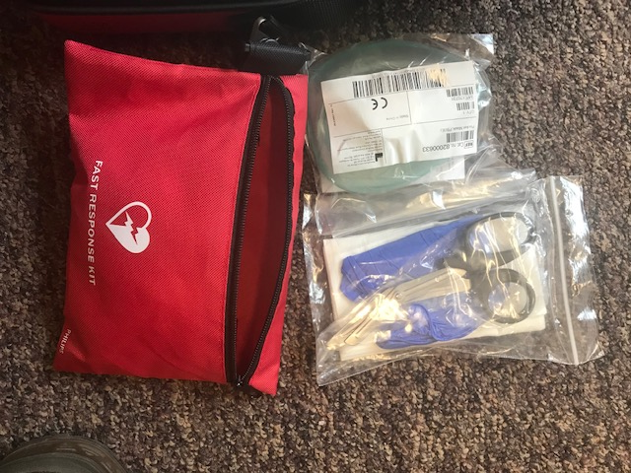

- Cabinet Alarm Functioning? – If the AED is stored in an alarmed cabinet, is the alarm functioning? If not, does the alarm battery need to be replaced, or does the alarm itself need to be repaired or replaced?

- Comments? – General comments about any actions taken or needed can be made here for each month. Things such as battery changes, replacing pads, etc. should be noted. If any problems are reported about the unit, copies of the correspondence should be kept on file along with this inspection form.

Recordkeeping: Monthly AED Inspection records are to be kept on file for the current and previous year and be made available to EHS when requested.

How to change the AED pads

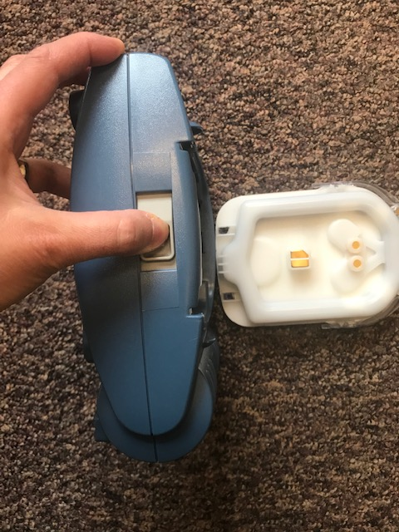
Push lever here to release the old pad pack.

Place new pad pack into the front of the AED and gently snap into place.

How to change the AED battery
Press tab here against the battery to pull the old batter out. Place new battery in this same slot.
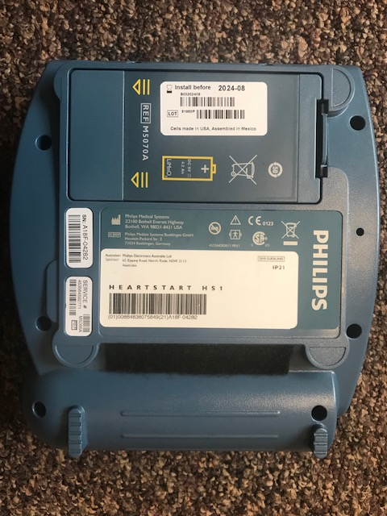

Automated External Defibrillator (AED) Monthly Inspection Form
Campus/Work Unit: ___________________________________
AED Building/Location: __________________________________
Make/Model/Serial Number: ________________________________________
Date | Inspector Initials | Unit Intact?  (Y/N) | Battery Functioning  (Y/N) | Pad Expiration Date | Rapid Response Kit Present & Intact? (Y/N) | Cabinet Alarm Functioning?  (Y/N/NA) | Comments
Notes: ____________________________________________________________________________________
____________________________________________________________________________________

