Radon and Radon Testing

The US Environmental Protection Agency and other organizations nationwide have dedicate January as National Radon Action Month to encourage the public to test their homes for radon and get radon problems fixed, see: http://www.epa.gov/radon001/nram/index.html

Did you know?
- According to the EPA, radon is the second leading cause of lung cancer, next to smoking, in the US, causing over 21,000 lung cancer deaths each year!
- Nearly 1 in 15 homes in the U.S. has elevated levels of radon.
- The U.S. Surgeon General and EPA recommend all homes be tested for radon.
- Radon testing is easy and inexpensive.
- Homes with elevated radon levels can be fixed.

Radon is a naturally occurring radioactive gas that comes from the decay of naturally occurring uranium and thorium in rocks and soils. It is found everywhere, even in the outside air, and has been a part of our environment since the beginning of time. Indoor radon levels can become elevated, especially in colder months, when your house is closed up and the heat is on. The combustion of fuels, or heated air loss from electric heat, causes the air pressure inside to be less than outside. It is this difference in air pressure that draws radon in from the soils surrounding your home. Any openings in the basement like sumps, drains, and cracks in the floor or walls, allows radon to enter. Porous foundation materials like unsealed cinder block can also let radon in.

Levels can vary greatly from one house to the next. It does not matter whether your house was constructed last week or 100 years ago, testing is the only way to know if your home has a high level of radon. In Pennsylvania professional testing and mitigating service providers are required to be certified and licensed by Pennsylvania’s Department of Environmental Protection, Bureau of Radiation Protection. A listing of these companies can be found on the State’s radon web page:

http://www.dep.pa.gov/Business/RadiationProtection/RadonDivision/Pages/default.aspx

Local companies are listed under “Radon Testing and Remediation Services” in the yellow pages. You can also buy sampling kits yourself. These kits come as either a short term or a long term version that you open and leave in your home for a few days (short term) or 6 to 12 months (long term). At the end of the sampling period you will need to mail the sampler to a processor for analysis. Be sure to follow the manufacturer’s instructions closely to ensure an accurate test.

If initial testing shows that you have an elevated level of radon, you will want to test again in a few months. The EPA recommended action level of 4 picocuries per liter of air (pCi/L) is meant to be a yearly average action level; a single result does not provide yearly average information. Consider short term testing once in each season and then averaging the results or purchase a long term test that provides a yearly average directly. If you’ve determined that mitigation is needed, check the State’s listing for certified and licensed radon mitigation professionals to perform the work. After the mitigation system is installed always have your home retested to insure levels have been reduced below the recommended action level.

For additional information check the State’s radon web page listed above or the EPA web page at: http://www.epa.gov/iaq/radon/ .
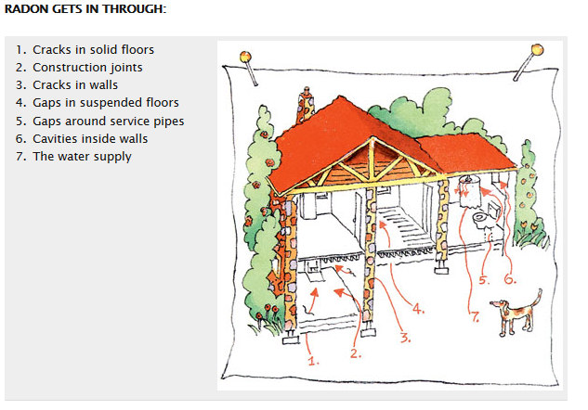

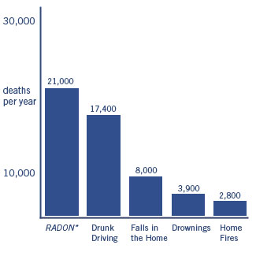

Radon is estimated to cause thousands of lung cancer deaths in the U.S. each year. EPA

