ENVIRONMENTAL HEALTH AND SAFETY

Trenching & Excavation Safety Program

Approvals:
Tony Cygan, MS, CSP
[Author/Program Manager]
Mark Linsenbigler, MS, CSP
[Reviewer/Supervisor] |  | [Other Management Approval]

Contents

1.0 Purpose 2

2.0 Introduction 2

3.0 Scope and Applicability 2

4.0 Terms and Definitions 2

5.0 Roles and Responsibilities 5

6.0 Resources, References, and Source Information 6

7.0 Standard EHS Program Information 7

8.0 Hazard Identification and Control 11

9.0 contractors 19

Appendix A. Trench & Excavation Inspection and Entry Authorization Checklist 21

Appendix B. OSHA Sloping and Benching Design Requirements 22

1.0 Purpose
This program has been established to accomplish the following objectives:
- Establish safe work practices to protect personnel from harm when working in or near trenches/excavations.
- Assign specific responsibilities pertaining to trench/excavation safety.
- Ensure compliance with OSHA safety regulations.

2.0 Introduction
Trenches and excavations are a potential source of workplace injuries. Most of these incidents can be prevented when proper safety precautions are implemented. This program will help ensure that the hazards are evaluated and eliminated.
Below are a few key points of this program that trigger required actions:
- Employees are required to be trained in trench/excavation safety when they enter trenches of approximately four feet or more in depth.
- Trenches/excavations that reach a depth of four feet or more require a stairway, ladder, ramp or other safe means of ingress/egress.
- Trenches/excavations that reach a depth of five feet or more, require protection from cave-ins provided by an adequate protective system.
- Documented inspections are required for trenches/excavations that reach a depth of five feet or more.
- Personnel working in excavations/trenches are required to wear the following PPE (at a minimum): Safety glasses, hardhat, gloves (as needed), high visibility vest/clothing, and safety shoes.

3.0 Scope and Applicability
This program applies to all PSU employees at all PSU locations except the Hershey Medical Center and the College of Medicine.
4.0 Terms and Definitions

Aluminum Hydraulic Shoring means a pre-engineered shoring system comprised of aluminum hydraulic cylinders (crossbraces) used in conjunction with vertical rails (uprights) or horizontal rails (wales). Such system is designed specifically to support the sidewalls of an excavation and prevent cave-ins.

Atmospheric Monitoring means instantaneous or continuous monitoring (testing) of hazardous or potentially hazardous atmospheres for suspected air contaminants, which at specific concentrations may pose a serious life safety risk to personnel working in or near trench and excavation sites.

Benching (Benching system) means a method of protecting employees from cave-ins by excavating the sides of an excavation to form one or a series of horizontal levels or steps, usually with vertical or near-vertical surfaces between levels.

Cave-in means the separation of a mass of soil or rock material from the side of an excavation, or the loss of soil from under a trench shield or support system, and its sudden movement into the excavation, either by falling or sliding, in sufficient quantity so that it could entrap, bury, or otherwise injure and immobilize a person.

Competent person means one who is capable of identifying existing and predictable hazards in the surroundings, or working conditions which are unsanitary, hazardous, or dangerous to employees, and who has authorization to take prompt corrective measures to eliminate them.

Cross braces mean the horizontal members of a shoring system installed perpendicular to the sides of the excavation, the ends of which bear against either uprights or wales.

Excavation means any man-made cut, cavity, trench, or depression in an earth surface, formed by earth removal.

Faces or Sides means the vertical or inclined earth surfaces formed as a result of excavation work.

Forced air ventilation means the delivery of forced air from a source that is not contaminated or itself hazardous, using appropriate explosion-proof or rated fans and associated ductwork to adequately reduce and control a hazardous atmosphere to permit safe working conditions, as determined by a competent person.

Hazardous atmosphere means an atmosphere which by reason of being explosive, flammable, poisonous, corrosive, oxidizing, irritating, oxygen deficient, toxic, or otherwise harmful, may cause death, illness, or injury.

Protective system means a method of protecting employees from cave-ins, from material that could fall or roll from an excavation face or into an excavation, or from the collapse of adjacent structures. Protective systems include support systems, sloping and benching systems, shield systems, and other systems that provide the necessary protection.

Ramp means an inclined walking or working surface that is used to gain access to one point from another, and is constructed from earth or from structural materials such as steel or wood.

Registered Professional Engineer (P.E.) means a person who is registered as a professional engineer in the state where the work is to be performed. However, a professional engineer, registered in any state is deemed to be a "registered professional engineer" within the meaning of this standard when approving designs for "manufactured protective systems" or "tabulated data" to be used in interstate commerce.

Shield (Shield system) means a structure that is able to withstand the forces imposed on it by a cave-in and thereby protect employees within the structure. Shields can be permanent structures or can be designed to be portable and moved along as work progresses. Additionally, shields can be either premanufactured or job-built in accordance with 1926.652(c)(3) or (c)(4). Shields used in trenches are usually referred to as "trench boxes" or "trench shields."

Shoring (Shoring system) means a structure such as a metal hydraulic, mechanical or timber shoring system that supports the sides of an excavation and which is designed to prevent cave-ins.

Sides. See "Faces."

Sloping (Sloping system) means a method of protecting employees from cave-ins by excavating to form sides of an excavation that are inclined away from the excavation so as to prevent cave-ins. The angle of incline required to prevent a cave-in varies with differences in such factors as the soil type, environmental conditions of exposure, and application of surcharge loads.

Stable rock means natural solid mineral material that can be excavated with vertical sides and will remain intact while exposed. Unstable rock is considered to be stable when the rock material on the side or sides of the excavation is secured against caving-in or movement by rock bolts or by another protective system that has been designed by a registered professional engineer.

Structural ramp means a ramp built of steel or wood, usually used for vehicle access. Ramps made of soil or rock are not considered structural ramps.

Support system means a structure such as underpinning, bracing, or shoring, which provides support to an adjacent structure, underground installation, or the sides of an excavation.

Trench (Trench excavation) means a narrow excavation (in relation to its length) made below the surface of the ground. In general, the depth is greater than the width, but the width of a trench (measured at the bottom) is not greater than 15 feet (4.6 m). If forms or other structures are installed or constructed in an excavation so as to reduce the dimension measured from the forms or structure to the side of the excavation to 15 feet (4.6 m) or less (measured at the bottom of the excavation), the excavation is also considered to be a trench.

Trench box. See "Shield”.

Trench shield. See "Shield."

Uprights means the vertical members of a trench shoring system placed in contact with the earth and usually positioned so that individual members do not contact each other. Uprights placed so that individual members are closely spaced, in contact with or interconnected to each other, are often called "sheeting."

Wales means horizontal members of a shoring system placed parallel to the excavation face whose sides bear against the vertical members of the shoring system or earth.

5.0 Roles and Responsibilities

Budget Executives and Budget Administrators:
    - Ensure that responsibilities assigned within this program are carried out within their administrative work unit.
    - Monitor implementation of this program within their work unit.
    - Ensure adequate funding is available to support this program.

Environmental Health and Safety Department:
- Assist work units in implementing the provisions of this program.
- Periodically audit compliance with program.
- Update this program as needed.

Office of Physical Plant (OPP), College of Agricultural Sciences (COAS) and Commonwealth Campus locations:
- Notify the Pennsylvania One Call system of intent to dig prior to starting work;
- Mark the locations of Penn State owned utilities, this does not include other non- PSU utilities for example; Verizon, Columbia Gas, telecom and etc.;
- Maintain utility markings;
- Perform the excavation work, or secure contractor to perform the work;
- Install the appropriate protective system for class C soil (Unless soil is required to be reclassified, see section 8.9);
- Ensure open trenches and excavations are secured or fenced when not attended;
- Perform trench inspections as needed (daily, weather change, condition change, etc);
- Submit any Alleged Violation Report (AVR) to Pennsylvania Public Utility Commission as applicable. A situation such as, but not limited to, damage to an underground line.

Commonwealth Services:
- (If contracting work on the campus’s behalf): Responsible for ensuring that the Commonwealth Campus’s Maintenance Department is notified prior to starting work.
- If contractor does the work, the contractor/utility companies are responsible for ensuring utilities are marked.

Safety Officers:
- Be thoroughly informed of the contents of this program and how it relates to their areas of responsibility and authority.
- Coordinate implementation within their work unit.
- Ensure training records are maintained.
- Assist in the investigation of injuries and incidents related to trenching within their work unit.

Supervisors:
- Ensure employees attend training.
- Ensure employees comply with this program.
- Be thoroughly informed of the contents of this program and how it applies to their areas of responsibility and authority.
- Investigate trenching injuries and incidents within their area of authority.
- Take prompt corrective action when unsafe conditions or practices are observed.

Employees:
- Comply with the requirements of this program.
- Attend training sessions as required.
- Report any concerns related to trenching/excavating to their immediate supervisor.

Contractors:
- Contractors are required to follow all applicable OSHA trenching/excavating regulations and manufacturer’s instructions pertaining to protective systems.
- Contractors are not allowed to utilize any University owned trench/excavation shoring/shielding equipment.

Excavation Contractor Responsibilities:
- Notify the Pennsylvania One Call system of intent to dig prior to starting work;
- Maintain utility markings;
- Perform the excavation work;
- Install the appropriate protective system for the soil class;
- Ensure open trenches and excavations are secured or fenced when not attended;
- Perform trench inspections as needed (daily, weather change, condition change, etc);
- Submit any Alleged Violation Report (AVR) to Pennsylvania Public Utility Commission as applicable. A situation such as, but not limited to, damage to an underground line.
- NOTE: see section 9.0 for Penn State University – Campus specific contractor requirements.

6.0 Resources, References, and Source Information
CFR 1926 – Subpart P – Excavations. Standard Number – 1926.650 - .652
CFR 1926 – Subpart M – Fall Protection. Standard Number – 1926.501 (b)(7)
PSU Confined Space Program. Found here: https://ehs.psu.edu/confined-space/confined-space-requirements-guidelines
PSU Environmental Emergency Plans. Found here: https://ehs.psu.edu/environmental-emergency-plans/overview

7.0 Standard EHS Program Information

7.1 Incident and Emergency Planning and Response
1. Spill (i.e. gas, oil, hydraulic, chemical)
- Refer to the program guidance link below for more information: https://ehs.psu.edu/environmental-emergency-plans/requirements-guidelines
2. Emergency medical emergency/rescue procedures
- Contact 911 immediately.
7.2 Near-Misses and Incident Reporting
An event is considered a near miss if no injuries occur. Examples include, but aren’t limited it, cave-in, discovering a utility service line that wasn’t appropriately indicated/marked, mobile equipment falling into trench/excavation.
The supervisor shall be notified of near-misses and incidents. The supervisor shall notify EHS.
7.3 Training Requirements
a. Competent Person Training:
- All trenching & excavation Competent Person Training (#1-6 below) will take place via third party classroom training.
- EHS must approve all third-party trainers.
- All PSU employees working inside a trench/excavation as well as those who dig/operate the excavation equipment must be trained to the Competent Person level.
A competent person shall be trained in the following:
1. Requirements of OSHA 29 CFR 1926 Subpart P;
2. Soil analysis.
3. Protective systems.
4. Conditions that could result in cave-ins;
5. Hazardous atmospheres;
6. Other hazards, including those associated with working in confined spaces;
7. Permit-Required Confined Space (PRCS) Training, including but not limited to, the use of a fall protection harness, use of air monitoring equipment, overview of assessment forms and the PRCS permit.
- This 2-part (online and hands-on) training is accessed and scheduled via the EHS Training Website: https://ehs.psu.edu/
8. Lock-Out/Tag-Out (as needed/depending on tasks conducted inside the trench/excavation).
a. This 1-part (in-person/classroom) training is scheduled via the EHS Training Website: https://ehs.psu.edu/

b. Student Training:
All students working inside a trench/excavation must complete the online Trenching/Excavation Training.
- The training is available online by logging into the EHS Training website, the link is located at https://ehs.psu.edu/.
c. Frequency of training:
- Competent Person training: Initial only- retraining typically not required (see “Retraining” section below).
- Student training: Initial only- retraining typically not required (see “Retraining” section below).
- Permit-Required Confined Space (PRCS): Initial only- retraining typically not required (see “Retraining” section below).
- Lock-Out/Tag-Out (as needed/depending on tasks conducted inside the trench/excavation): Initial only- retraining typically not required (see “Retraining” section below).
d. Retraining:
Situations requiring retraining include, but are not limited to, the following:
• When changes in the workplace or equipment render previous training obsolete or inadequate;
• When inadequacies in an affected employee's knowledge or use of equipment indicate that the employee no longer has the requisite understanding or skill necessary to use equipment or perform the job safely.

Documentation & Recordkeeping

Summary of Customer Record Retention Requirements
Records Series  (Types of Documents) | Record Description | Records Series Description | Retention Period
Inspections | Appendix A – Trench & Excavation Inspection and Entry Authorization Checklist | Inspection conducted by the Competent Person before work can begin. | End of calendar year + 1 year.
Training Records & Sign-in Sheets | Sign-in Sheets or equivalent | Training for Competent Persons and Trench/Excavation Users shall be documented. | End of calendar year in which course ends or separation of employment + 30 years

Minimum Program Metrics and Evaluation
This section represents minimum planned frequencies for these activities. Additional, more frequent inspections, audits, or evaluations may occur as needed to address regulatory changes, regulatory requests, observed trends, corrective actions, or other EHS concerns.
• EHS will periodically audit compliance with program.

Non-Compliance
A trench & excavation activity will be considered in a state of non-compliance if any of the requirements defined by this program are not followed. If non- compliance issue exists, the trench/excavation must be vacated immediately until all non-compliance items are corrected.

8.0 Hazard Identification and Control

8.1 Competent Person
A competent person shall be assigned to each trench/excavation that reaches a depth of five feet or more.
8.2 Marking of Utilities
The estimated location of utility installations, such as sewer, telephone, fuel, electric, water lines, or any other underground installations that reasonably may be expected to be encountered during excavation work, shall be determined prior to opening an excavation.
Contact Pennsylvania One Call by dialing “811” to schedule this process.
- OPP marks University owned utilities at UP.
- Utility company marks the utilities owned by them.
- Commonwealth Campuses mark the utilities owned by them.
8.2 Inspection
The competent person shall conduct inspections for trenches/excavations that reach a depth of five feet or more. The competent person may determine the need to conduct inspections at lesser depths, depending on the extent and nature of site hazards present.
The inspection checklist shall be completed:
a. Daily and before the start of each shift.
b. As dictated by the work being done in the trench (i.e. welding, hotwork, when water/gas utility lines running through/along trench).
c. After every rainfall.
d. After other events occur that could increase hazards or change conditions, such as snowstorm, windstorm, thaw, earthquake, dramatic change in weather, etc.
e. When fissures, tension cracks, sloughing, undercutting, water seepage, bulging at the bottom, or other similar conditions occur.
f. When there is a change in the size, location, or placement of the spoil pile.
g. When there is any indication of change or movement in adjacent structures.
h. When any unknown or unanticipated odor is detected upon planned entry to a trench or excavation. In such cases, workers shall immediately exit and conduct air monitoring to verify a hazardous atmosphere does not exist, prior to re-entry.
8.3 Stability of Adjacent Structures
Where the stability of adjoining buildings, walls, or other structures is endangered by excavation operations, support systems such as shoring, bracing, or underpinning shall be provided to ensure the stability of such structures for the protection of personnel.
Excavations below the level of the base or footing of any foundation or retaining wall that could be reasonably expected to pose a hazard to employees shall not be permitted.
A registered professional engineer is required to make these determinations and corrective actions.
8.4 Crossing over a Trench/Excavation (via walking or by vehicle)
Surface crossings shall not be made unless necessary.
Crossing narrow trenches (30 inches or less in width) without a walkway is permitted. Walkways / bridges with standard guardrails must be provided when employees or equipment are required or permitted to cross over trenches when the excavation is 6 feet or more in depth and wider than 30 inches at the top.
If access across a trench/excavation is required by vehicle, a registered Professional Engineer is required for this design.

8.5 Protection of the Public (i.e. faculty, staff, student, visitor)
When leaving an trench/excavation open and unattended, measures shall be taken to prevent unauthorized access. When an excavation is unattended and in excess of 1 foot in depth a barrier fence is required surrounding the excavation.
When an excavation is less than a foot in depth, other types of barricades are acceptable (ex. cones and caution tape).
Fencing is required for depressions left by the removal of trees unless the depression is backfilled at once.
On farms, where field tilling projects or research activities may make fencing impractical, an equally effective means of barricading shall be employed.
8.6 Fall Protection
The edge of trenches/excavations 6 feet or more in depth shall be protected by guardrail systems, fences, or barricades when the excavations are not readily seen because of plant growth or other visual barrier.
- In other words, unless the trench/excavation is obscured from view, no fall protection is required.
This exemption does not apply to the edge of a wells, pits, shafts, and similar excavations 6 feet or more in depth. They shall be protected by guardrail systems, fences, barricades, or covers.
8.7 Protection of Personnel in a Trench/Excavation.
Access/Egress-
Trenches/Excavations four feet or more in depth shall be provided with a means of egress. Typically, this will be accomplished by use of a ladder. Spacing between ladders or other means of egress must be such that a worker will not have to travel more than 25 feet laterally to the nearest means of egress.
Ladders must be secured and extend a minimum of 36 inches above the landing. Metal ladders should not be used when electric utilities are present in the trench/excavation.

Protection from Falling Materials
No employee shall be permitted underneath loads handled by lifting or digging equipment. Employees shall be required to stand away from any vehicle being loaded or unloaded to avoid being struck by any spillage or falling materials.
Equipment operators or truck drivers may remain in their equipment during loading and unloading if the equipment is properly equipped with a cab shield or adequate canopy.
When mobile equipment is operated adjacent to a trench/excavation, or when such equipment is required to approach the edge of an trench/excavation, and the operator does not have a clear and direct view of the edge, a warning system shall be utilized such as barricades, hand or mechanical signals, or stop logs. If possible, the grade should be away from the excavation.
Soil and Material Placement
Any surface encumbrances, or impediments, that are located in a position that could create a hazard to employees in or around the excavation shall be removed or supported to safeguard employees.
Personnel shall be protected from excavated or other materials or equipment that could pose a hazard by falling or rolling into trench/excavation. All soil and rock removed during the excavation shall be placed at least two (2) feet from the edge of the excavation. If more protection is needed, the use of retaining devices that are sufficient to prevent materials or equipment from falling or rolling into excavations is necessary.

Water Accumulation –
Personnel are not permitted to work in or around trenches during rainfall events.
Trenches/excavations must be inspected by the competent person after rainfall events before allowing re-entrance.
Work is not permitted in excavations in which there is accumulated water, or in excavations in which water is accumulating, unless adequate precautions have been taken. The precautions necessary to protect employees adequately vary with each situation, but could include special support or shield systems to protect from cave-ins, or water removal to control the level of accumulating water.
If water is controlled or prevented from accumulating by the use of water removal equipment, the water removal equipment and operations shall be monitored by a competent person to ensure proper operation. Equipment with internal combustion engines should be located as far from the trench as possible. The competent persons shall determine where the equipment shall be located based on site conditions. Typically a 50 foot minimum separation shall be made from the trench/worker area, and operating equipment downstream of trench area; however, this may be changed depending on site conditions, as determined by the competent person.
If excavation work interrupts the natural drainage of surface water (such as streams), diversion ditches, dikes, or other suitable means shall be used to prevent surface water from entering the excavation and to provide adequate drainage of the area adjacent to the excavation. Excavations subject to runoff from heavy rains will require an inspection by a competent person.
Personal Protective Equipment (PPE) –
Personnel working in excavations/trenches are required to wear the following PPE (at a minimum): Safety glasses, hardhat, gloves (as needed), high visibility vest/clothing, and safety shoes.
8.8 Hazardous Atmosphere -
Hazardous atmospheres may occur within trenches and related excavations and may occur without warning. Many vapors or gaseous agents may accumulate beneath grade, similarly to sub-grade confined spaces. Such gases or vapors may be odorless, may be denser than air, and can pose imminent life-threatening danger to personnel entering trenches and excavations to perform work.
The following types of conditions warrant conducting a preliminary hazard assessment by the competent person, and prospective air monitoring to assess life-threatening atmospheric hazards on a construction site, or in proximity to a trench/excavation:
- Subterranean/buried or gas utility lines, connections, or terminations through or near the trench or excavation (particularly in known Type B or Type C soils),
- Subterranean or above-grade gasoline or fuel storage tanks,
- Other gas cylinder storage,
- Cryogen tanks or storage vessels,
- Nearby or corresponding hazardous waste clean-up or contaminated sites,
- Gas cylinders brought into trenches to perform welding or necessary work,
- Substantive sources of powder insulation, or other finely divided dusts which may pose a combustible atmosphere,
- Substantive sources of other work materials that may produce vapors or harmful agents that may build-up within a trench or excavation.
NOTE: These conditions may develop rapidly, and may occur without warning:
- Flammable or combustible atmosphere
- Oxygen-deficient or oxygen-enriched atmosphere
- Toxic gas build-up that may incapacitate a trench or excavation worker

EXAMPLE: Certain gases such as propane, carbon dioxide, and hydrogen sulfide are heavier than air (specific gravity > 1) and may build-up within or fill a sub-grade trench (<4’ depth), where undetected by odor. Certain gases and solvent vapors may also pose a flammability hazard, such that site conditions must be assessed by the competent person.
Wherever the competent person identifies potential hazardous atmospheres on or near a job site, these conditions must be controlled and abated prior to trench/ excavation entry (e.g. liquid fuel catch basins, re-routing or suspending source activity, etc.).
Personnel shall not work in/exit trenches or excavations with notable hazardous atmospheres, or indications that a hazardous atmosphere is developing.
Any trench or excavation in which the competent person deems forced air ventilation (via explosion-proof fans, etc.) necessary to maintain safe working conditions (free of hazardous atmospheres), shall also be classified as a permit-required confined space (PRCS), and entry is subject to requirements of the Penn State Confined Space Program. Such work will be governed by a Penn State confined space permit, with all appropriate precautions and rescue provisions. All other appropriate controls shall be used as applicable to the trench/excavation work.
Atmospheric monitoring instruments shall be calibrated and maintained in accordance with requirements by the instrument manufacturer, and/or pursuant to requirements outlined in the Penn State Confined Space Program, and to the OSHA trenching/excavation standards.
Some of these requirements include:
- Pre-entry testing wherever trenches/excavations exceed a four foot depth in landfill areas or where hazardous substances are stored nearby, and where such conditions may result in OSHA-defined oxygen-deficiency (<19.5% oxygen).
- Providing necessary forced air ventilation (FAV) or respiratory protection during work in conditions with potential oxygen-deficiency.
- Providing adequate FAV to prevent build-up of a gas or vapor which exceeds 20% of its corresponding lower explosive-flammable limit (LEL or LFL). [note refer to confined space definition].
- Wherever controls are required to maintain safe working conditions, continuous or frequent (e.g. each 15-minutes) air monitoring shall be required.

8.9 Soil Classification
Soil Classification is a method of categorizing soil and rock deposits in a hierarchy of Stable Rock, Type A, Type B, and Type C, in decreasing order of stability. The categories are determined based on an analysis of the properties and performance characteristics of the deposits and the environmental conditions of exposure.
Stable Rock – natural solid mineral matter that can be excavated with vertical sides and remain intact while exposed. NOTE: trenches/excavations in stable rock are not required to be protected from cave-ins by protective systems.
Type A - Most stable: clay, silty clay, and hardpan (resists penetration). No soil is Type A if it is fissured, is subject to vibration of any type, has previously been disturbed, or has seeping water.
Type B - Medium stability: silt, sandy loam, medium clay and unstable dry rock; previously disturbed soils unless otherwise classified as Type C; soils that meet the requirements of Type A soil but are fissured or subject to vibration.
Type C - Least stable: gravel, loamy sand, soft clay, submerged soil or dense, heavy unstable rock, and soil from which water is freely seeping.
Layered geological stratifications – When soils are configured in layers - The soil must be classified on the basis of the classification of the weakest layer. Each layer may be classified individually if a more stable layer lies below a less stable layer, i.e. where a Type C soil rests on top of stable rock.
ALL SOIL, AT ANY UNIVERSITY LOCATION, WILL BE CLASSIFIED AS TYPE C.
- Any deviation from this soil classification requires notifying EHS, work unit/campus safety officer, and the maintenance department (if at CWC) prior to starting work.
8.10 Protective Systems
Trenches/excavations reaching five feet require one of the following types of protective systems.
Shielding – Protective System
Trench shields or trench boxes are different from shoring because they are intended primarily to shield workers from cave-ins and similar incidents rather than support the walls from caving.
a. The excavated area between the outside of the trench box and the face of the trench should be as small as possible. The space between the trench box and the excavation side must be backfilled to prevent lateral movement of the box.
b. Shields may not be subjected to loads exceeding those which the system was designed to withstand.
c. Trench boxes are generally used in open areas, but they also may be used in combination with sloping and benching.
d. The trench box must extend at least 18 inches above the surrounding area if there is sloping toward the excavation. This can be accomplished by providing a benched area adjacent to the box.
e. Any modifications to the shields must be approved by the manufacturer.
f. Shields may ride two feet above the bottom of an excavation, provided they are calculated to support the full depth of the excavation and there is no caving under or behind the shield.
g. Workers must enter and leave the shield in a protected manner, such as by a ladder or ramp.
h. Workers shall not be permitted to remain in the shield while it is being moved.

Sloping – Protective System
Sloping is a protective measure that cuts the walls of the excavation back at an angle from the floor to produce a stable slope. The slope angle is based on soil type. The flatter the angle of the slope, the greater the protection factor for the employee.
• Type A Soil: The ratio is 3/4 ft. horizontal for every foot vertical (53° from the horizontal)
• Type B Soil: The ratio is 1 ft. horizontal for every foot vertical (45° from the horizontal)
• Type C Soil: The ratio is 11/2 ft. horizontal for every one foot vertical (34° from the horizontal)
Maximum allowable slopes and sloping configurations will be determined according to soil type as described in Appendix B.
Benching – Protective System
There are two basic types of benching, single and multiple, which can be used in conjunction with sloping. In Type B soil, the vertical height of the benches must not exceed 4 feet. Benches must be below the maximum allowable slope for that soil type.
Benching alone is not adequate protection in Class C soil.
Benching must be installed in accordance with Appendix B.
Shoring – Aluminum pneumatic/hydraulic shoring – Protective System
Shoring is used when the location or depth of the cut makes sloping back to the maximum allowable slope impractical.
Air shoring provides a critical safety advantage over timber shoring because workers do not have to enter the trench to install them. They are also light enough to be installed by one worker; they are gauge-regulated to ensure even distribution of pressure along the trench line; and they can be adapted easily to various trench depths and widths.
All shoring shall be installed from the top down and removed from the bottom up. Air shoring shall be checked at least once per shift for leaking hoses and/or cylinders, broken connections, cracked nipples, bent bases, and any other damaged or defective parts.
The top cylinder of air shoring shall be no more than 18 inches below the top of the excavation.
The bottom cylinder shall be no higher than four feet from the bottom of the excavation. (Two feet of trench wall may be exposed beneath the bottom of the rail or plywood sheeting, if used.)
Three vertical shores, evenly spaced, must be used to form a system.
Wales are installed no more than two feet from the top, no more than four feet from the bottom, and no more than four feet apart, vertically.
Air shores must be installed in accordance with Appendix B.

Timber Shoring – Protective System
Shall not be installed by PSU employees (3rd party only).

9.0 Contractors
University Park locations: Contractors must contact OPP prior to any trenching/excavation work. This is to ensure that the project’s impact to utilities has been reviewed and to ensure the identification and marking of underground utilities has been conducted (sewer, telecommunication, gas, water, steam, electric, etc.).
Commonwealth Campus locations: Contractors must contact the maintenance department prior to any trenching/excavation work. This is to ensure that the project’s impact to utilities has been reviewed and to ensure the identification and marking of underground utilities has been conducted (sewer, telecommunication, gas, water, steam, electric, etc.).

Revision History

Revision Date | Purpose or Description
3/2023 | Original / New PSU Program

TRENCH & EXCAVATION INSPECTION AND ENTRY AUTHORIZATION CHECKLIST
LOCATION: |  |  |  |  |  |  | DATE:
TIME OF INSPECTION(S):
WEATHER CONDITIONS: |  |  |  |  |  | APPROX. TEMPERATURE:
COMPETENT PERSON: |  |  |  |  | SUPERVISOR:
DIMENTIONS: | DEPTH = |  |  |  | Yes No HAZARDOUS CONDITIONS
 | TOP = | W |  | L | q q .......... Saturated soil / standing or seeping water
 | BOTTOM = | W |  | L | q q .......... Cracked or fissured wall(s)
SOIL TYPE: |  |  | TESTED: |  | q q .......... Bulging wall(s)
q Stable Rock |  |  | q Yes |  | q q .......... Floor heaving
q Type A Soil |  |  | q No |  | q q .......... Frozen soil
q Type B Soil |  |  |  |  | q q .......... Excess loads/weights near edge (i.e. crane, vehicle, equipment)
q Type C Soil – any trench/excavation dug by PSU personnel shall be considered TYPE C soil. Exemption required for changing soil type. |  |  |  |  | q q .......... Vibration
 |  |  |  |  | q q .......... Depth greater than 10’ (i.e. depth at which two trench boxes are needed/stacked)
PROTECTION METHOD UTILIZED: |  |  |  |  | PLACEMENT OF SPOILS & EQUIPMENT
q Sloping / Benching 1-1/2:1 (Type C Soil)S |  |  |  |  | q q .......... Spoils at least two feet from edge of trench
q Sloping / Benching 1:1 (Type B Soil) |  |  |  |  | q q .......... Equipment at least two feet from edge
q Sloping / Benching 3/4:1 (Type A Soil) |  |  |  |  | q q .......... Backhoe at end of trench
q Sloping / Benching Vertical (Stable Rock) |  |  |  |  | q q .......... Compressor, etc. at remote location
q Pneumatic Spreaders |  |  |  |  | LADDER LOCATION
q Hydraulic Spreaders |  |  |  |  | q q .......... Located in protected area
q Trench Box |  |  |  |  | q q .......... Within 25 feet of safe travel
q Other (Describe in detail) IRREGULAR WALLS |  |  |  |  | q q .......... Secured
q Trench over 20’ deep requires P.E. certification |  |  |  |  | q q .......... Extends 36 inches above the landing
 |  |  |  |  | q q .......... Leads to safe landing
Yes No ENVIRONMENTAL CONDITIONS: |  |  |  |  | OTHER:
q q Gas detector used? |  |  |  |  | q q Shoring equip. & mats inspected prior to use?
q q Hazardous atmosphere potential/present? |  |  |  |  | q q Is trench SAFE to enter?
q q Confined space permit issued?
COMMENTS:
All unsafe conditions must be corrected prior to entry. If any hazardous conditions appear during the course of work the trench must be immediately evacuated.
Competent Person signature:
Version 1 – Original - created 3/2023

(a) Scope and application. This appendix contains specifications for sloping and benching when used as methods of protecting employees working in excavations from cave-ins. The requirements of this appendix apply when the design of sloping and benching protective systems is to be performed in accordance with the requirements set forth in § 1926.652(b)(2).
(b) Definitions.
Actual slope means the slope to which an excavation face is excavated.
Distress means that the soil is in a condition where a cave-in is imminent or is likely to occur. Distress is evidenced by such phenomena as the development of fissures in the face of or adjacent to an open excavation; the subsidence of the edge of an excavation; the slumping of material from the face or the bulging or heaving of material from the bottom of an excavation; the spalling of material from the face of an excavation; and ravelling, i.e., small amounts of material such as pebbles or little clumps of material suddenly separating from the face of an excavation and trickling or rolling down into the excavation.
Maximum allowable slope means the steepest incline of an excavation face that is acceptable for the most favorable site conditions as protection against cave-ins, and is expressed as the ratio of horizontal distance to vertical rise (H:V).
Short term exposure means a period of time less than or equal to 24 hours that an excavation is open.
(c) Requirements -- (1) Soil classification. Soil and rock deposits shall be classified in accordance with appendix A to subpart P of part 1926.
(2) Maximum allowable slope. The maximum allowable slope for a soil or rock deposit shall be determined from Table B-1 of this appendix.
(3) Actual slope. (i) The actual slope shall not be steeper than the maximum allowable slope.
(ii) The actual slope shall be less steep than the maximum allowable slope, when there are signs of distress. If that situation occurs, the slope shall be cut back to an actual slope which is at least ½ horizontal to one vertical (½H:1V) less steep than the maximum allowable slope.
(iii) When surcharge loads from stored material or equipment, operating equipment, or traffic are present, a competent person shall determine the degree to which the actual slope must be reduced below the maximum allowable slope, and shall assure that such reduction is achieved. Surcharge loads from adjacent structures shall be evaluated in accordance with § 1926.651(i).
(4) Configurations. Configurations of sloping and benching systems shall be in accordance with Figure B-1.

TABLE B-1
MAXIMUM ALLOWABLE SLOPES
SOIL OR ROCK TYPE | MAXIMUM ALLOWABLE SLOPES (H:V)(1) FOR EXCAVATIONS LESS THAN 20 FEET DEEP(3)
STABLE ROCK  TYPE A (2)  TYPE B  TYPE C | VERTICAL (90º)  3/4:1 (53º)  1:1 (45º)  1 ½:1 (34º)
Footnote(1) Numbers shown in parentheses next to maximum allowable slopes are angles expressed in degrees from the horizontal. Angles have been rounded off.
Footnote(2) A short-term maximum allowable slope of 1/2H:1V (63º) is allowed in excavations in Type A soil that are 12 feet (3.67 m) or less in depth. Short-term maximum allowable slopes for excavations greater than 12 feet (3.67 m) in depth shall be 3/4H:1V (53º).
Footnote(3) Sloping or benching for excavations greater than 20 feet deep shall be designed by a registered professional engineer.
Figure B-1
Slope Configurations
(All slopes stated below are in the horizontal to vertical ratio)
B-1.1 Excavations made in Type A soil.
1. All simple slope excavation 20 feet or less in depth shall have a maximum allowable slope of ¾:1.
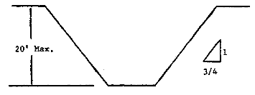
SIMPLE SLOPE -- GENERAL
Exception: Simple slope excavations which are open 24 hours or less (short term) and which are 12 feet or less in depth shall have a maximum allowable slope of ½:1.
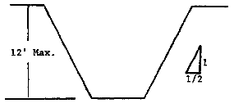
SIMPLE SLOPE -- SHORT TERM

2. All benched excavations 20 feet or less in depth shall have a maximum allowable slope of 3/4 to 1 and maximum bench dimensions as follows:
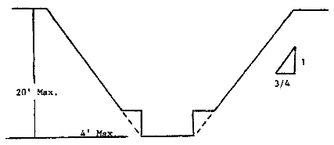
SIMPLE BENCH
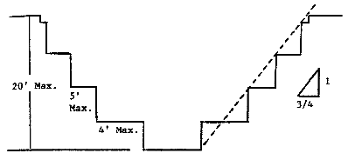
MULTIPLE BENCH
3. All excavations 8 feet or less in depth which have unsupported vertically sided lower portions shall have a maximum vertical side of 3½ feet.
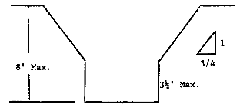

UNSUPPORTED VERTICALLY SIDED LOWER PORTION -- MAXIMUM 8 FEET IN DEPTH)
All excavations more than 8 feet but not more than 12 feet in depth with unsupported vertically sided lower portions shall have a maximum allowable slope of 1:1 and a maximum vertical side of 3½ feet.
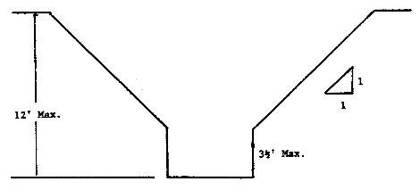
UNSUPPORTED VERTICALLY SIDED LOWER PORTION -- MAXIMUM 12 FEET IN DEPTH)
All excavations 20 feet or less in depth which have vertically sided lower portions that are supported or shielded shall have a maximum allowable slope of ¾:1. The support or shield system must extend at least 18 inches above the top of the vertical side.
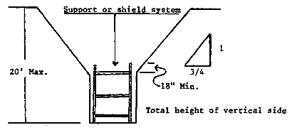
SUPPORTED OR SHIELDED VERTICALLY SIDED LOWER PORTION
4. All other simple slope, compound slope, and vertically sided lower portion excavations shall be in accordance with the other options permitted under § 1926.652(b).

B-1.2 Excavations Made in Type B Soil
1. All simple slope excavations 20 feet or less in depth shall have a maximum allowable slope of 1:1.
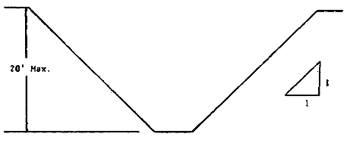
SIMPLE SLOPE
2. All benched excavations 20 feet or less in depth shall have a maximum allowable slope of 1:1 and maximum bench dimensions as follows:
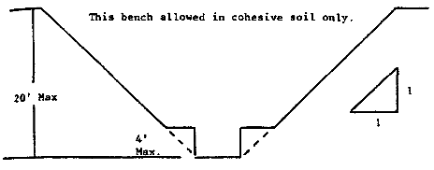
SINGLE BENCH
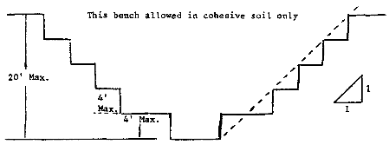
MULTIPLE BENCH

3. All excavations 20 feet or less in depth which have vertically sided lower portions shall be shielded or supported to a height at least 18 inches above the top of the vertical side. All such excavations shall have a maximum allowable slope of 1:1.
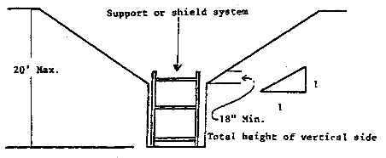
VERTICALLY SIDED LOWER PORTION
4. All other sloped excavations shall be in accordance with the other options permitted in § 1926.652(b).

B-1.3 Excavations Made in Type C Soil
1. All simple slope excavations 20 feet or less in depth shall have a maximum allowable slope of 1½:1.
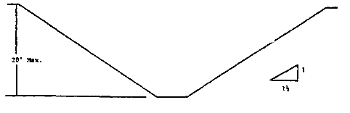
SIMPLE SLOPE

2. All excavations 20 feet or less in depth which have vertically sided lower portions shall be shielded or supported to a height at least 18 inches above the top of the vertical side. All such excavations shall have a maximum allowable slope of 1½:1.
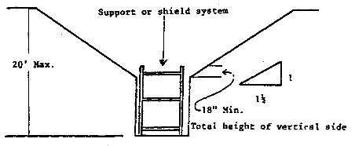
VERTICAL SIDED LOWER PORTION
3. All other sloped excavations shall be in accordance with the other options permitted in § 1926.652(b).
B-1.4 Excavations Made in Layered Soils
1. All excavations 20 feet or less in depth made in layered soils shall have a maximum allowable slope for each layer as set forth below.
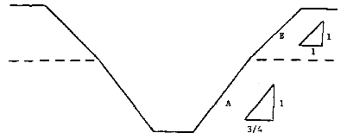
B OVER A
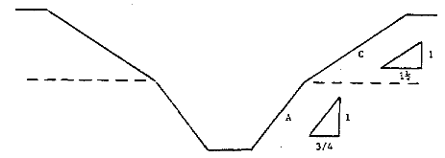
C OVER A
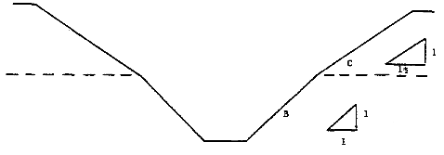
C OVER B
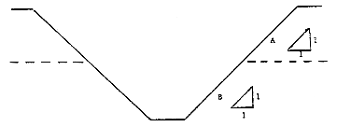
A OVER B
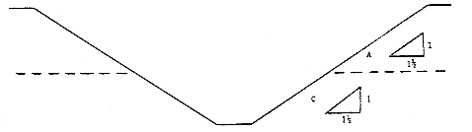
A OVER C
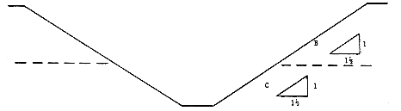
B OVER C

2. All other sloped excavations shall be in accordance with the other options permitted in § 1926.652(b).

