Procedures for Penn State Implementation
of the
Spotted Lanternfly Quarantine Requirements

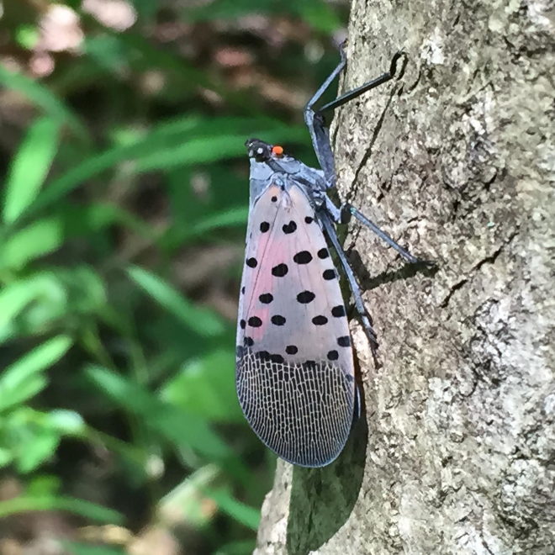
Photo: Penn State Extension

May 3, 2019
Revised March 29, 2022
Document Number: EHS-0037
Table of Contents

1.0 Purpose 1
2.0 Scope 1
3.0 Responsibilities 2
4.0 Spotted Lanternfly Facts 3
5.0 Procedures 4
5.1 The Spotted Lanternfly Quarantine 4
5.2 Selecting a Spotted Lanternfly Designated Employee 5
5.3 Spotted Lanternfly Designated Employee Tasks 5
5.4 Vehicle and Other Regulated Articles Inspections by Employees 7
5.5 Short-Term Fleet Rentals 7
5.6 Contractors and Vendors 8
5.7 Control of the Spotted Lanternfly on Properties within the Quarantine Zone 8
5.8 Reporting a Spotted Lanternfly Found Outside the Quarantine Zone 8
6.0 Recordkeeping 8
7.0 Flow Charts 9
8.0 Forms 13
9.0 Revision Summary Table 19

Purpose

The Spotted Lanternfly (SLF), is an invasive insect that has spread throughout southeastern Pennsylvania since its discovery in Berks County in 2014. This insect has the potential to greatly impact agricultural crops in Pennsylvania including grapes, hops, and hardwoods. It is also reducing the quality of life for people living in heavily infested areas. Penn State’s College of Agricultural Sciences, the United States Department of Agriculture (USDA), and the PA Department of Agriculture (PDA) have joined forces to control and contain the spread of SLF. Penn State has been leading the research efforts currently underway on the insect’s biology, pesticide studies and other control measures, and the ability of the SLF to adapt to the environment in Pennsylvania. They have also been the lead in communicating Quarantine requirements to businesses and in communicating measures to control the Spotted Lanternfly to homeowners.

To help slow the spread of the SLF, on May 26, 2018 the PDA implemented an Order of Quarantine for the Spotted Lanternfly (Quarantine). The order applies to all businesses that travel within, into, or out of the Quarantine Zone, including Penn State. The purpose of this document is to provide procedures to meet the Quarantine requirements.

Scope

These procedures apply to all personnel at all Penn State colleges, campuses, and other locations, with the exception of the Hershey Medical Center and College of Medicine, that will be driving into, out of, or within the Quarantine Zone on university business in either their personal vehicle or a university vehicle. The Quarantine Zone currently covers 45 counties and includes almost all of the campuses as well as other Penn State locations such as the Navy Yard and County Extension offices. The map below shows the current Quarantine Zone; however, it is subject to revision if the Spotted Lanternfly expands its reach. The EHS Spotted Lanternfly Resources website will be updated with any changes to the quarantine area.

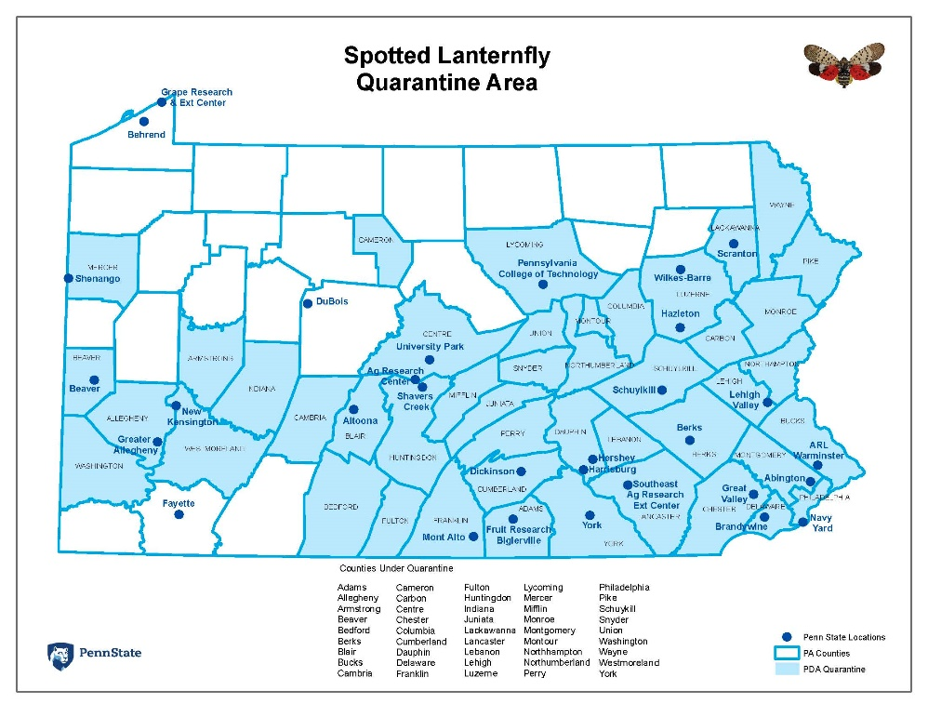

Responsibilities

All persons entering the Quarantine area, as well as specific personnel designated by their campus, college, or unit at Penn State are responsible to comply with this program.

Budget Executives and Budget Administrators must:
- Ensure that responsibilities assigned with this Quarantine are carried out within their administrative work unit;
- Assist the Campus Director of Business Services or the Safety Officer in appointing the person(s) who will serve as the Spotted Lanternfly Designated Employee(s);
- Ensure that personnel in their campus/college/unit are aware of the expectation that they comply with the Quarantine requirements and hold them accountable; and
- Monitor implementation of this program within their work unit.

Campus Director of Business Services and College/Unit Safety Officers must:
- Be thoroughly informed of the requirements of the Quarantine and how it relates to their areas of responsibility;
- Coordinate implementation of the Quarantine requirements within their work unit;
- Appoint the Spotted Lanternfly Designated Employee(s) and assist them with determining who is responsible for vehicles within their work unit;
- Provide the contact information for the Spotted Lanternfly Designated Employee(s) for the work unit to EHS;
- Ensure that the Spotted Lanternfly Designated Employees complete the annual self-audit and submit it to Campus Director of Business Services or College/Unit Safety Officers, and to EHS;
- Ensure that records are maintained for their work unit in accordance with the Quarantine.

Spotted Lanternfly Designated Employee must:
- Take the online “Spotted Lanternfly Permit Training for Businesses” required by the Quarantine;
- Upon passing the training, request the number of permits needed for the vehicles under the control of the campus/college/unit/department for which they are assigned;
- Ensure that anyone within their assigned group using a vehicle on university business in the Quarantine area is trained and that the employee provides the SLF Designated Employee with the training records;
- Ensure that SLF kits are assembled and placed in the vehicles under their purview;
- Maintain all training records indefinitely and the vehicle inspection records for two years; and
- Annually complete a self-audit and submit to their Campus Director of Business Services or College/Unit Safety Officer and to EHS.

Employees that will be driving into, out of, or within the Quarantine Zone on university business must:
- Take the required Spotted Lanternfly Quarantine training on Penn State’s Learning Resource Network (https://lrn.psu.edu/)
- Take precautions to ensure that you are not carrying the Spotted Lanternfly within your clothing or personal belongings;
- Inspect your vehicle and any other items that you may be transporting as required for the presence of the Spotted Lanternfly to the best of your ability;
- Document the inspection on the required form when applicable and provide this to your Spotted Lanternfly Designated Employee for department-controlled vehicles, long-term (permanently assigned) vehicles from Fleet Operation, or personal vehicles used for University business; and
- When using short-term (daily) rentals from Fleet Operations, document the inspection when applicable on the required form and provide this to Fleet Operations upon return of the vehicle.

College of Agricultural Sciences Associate Dean and Director of Special Programs must:
- Ensure everyone is aware of and knows how to access Spotted Lanternfly publications and materials;
- Inform EHS when changes to the Quarantine Zone occur to ensure that this information is disseminated to Penn State employees; and
- Serve as Spotted Lanternfly experts to the Penn State community.

Environmental Health and Safety (EHS) Department must:
- Provide implementation oversight and assist work units in implementing the Quarantine requirements;
- Ensure that the Penn State training materials are available for employees; and
- Ensure that self-audits are completed by all Spotted Lanternfly Designated Employees.

Spotted Lanternfly Facts

The Spotted Lanternfly (Lycorma delicatula) is a planthopper from the order Hemiptera like other native aphids, cicadas, or leafhoppers. They have piercing sucking mouthparts that are used to feed on sap from the trunks, stems, or leaves of trees, and cannot bite or sting people. Although their preferred diet is Ailanthus altissima tree (tree of heaven), they have the potential to have a devastating effect on agriculture in Pennsylvania. In addition, they produce honeydew, a clear, sticky, sugar-rich substance, which attracts stinging insects and enables a black sooty mold to grow, causing unpleasant conditions for homeowners.

The SLF life cycle is important to know. They hatch in the spring as wingless black nymphs with white spots and can be easy to overlook, as they are small and look somewhat like ants. They molt several times (each new nymph is called an instar), but by the fourth stage, they are more conspicuous, are larger, and red, black, and white in color. The final molt into adults begins somewhere around the third week of July, but individuals can remain in the late nymph stage as late as September. Around the third week in September, they begin mating, and then they lay masses of 30-50 eggs, which are contained in a plaster-like covering. The adults will continue to feed intermittently after egg laying and live until a heavy frost kills them. Undisturbed egg masses will overwinter and then hatch in the spring. The life cycle is shown in the infographic below (Colleen Witkowski, Penn State).

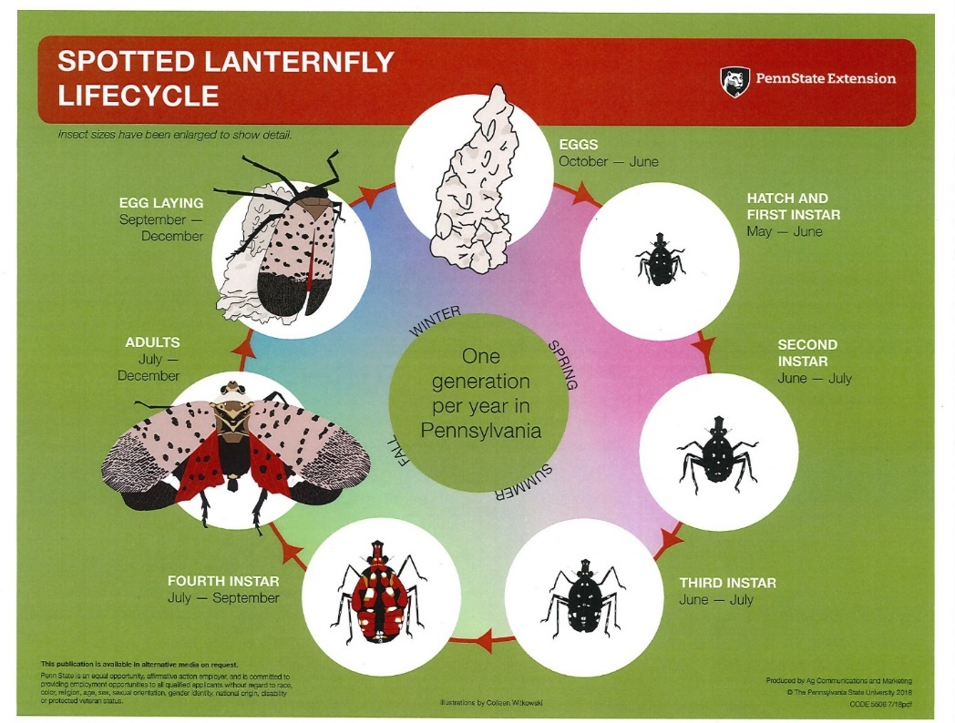

Procedures

The Spotted Lanternfly Quarantine
The Spotted Lanternfly Order of Quarantine and Treatment was issued by the Pennsylvania Department of Agriculture on May 26, 2018 and it was updated and replaced last on March 26, 2022. While it is understood that the Quarantine will likely not stop the eventual spread of this pest, it will provide time to learn better ways to control it. It also assures Pennsylvania’s trading partners that we are doing all we can to prevent it from spreading to other states on regulated articles.

The Quarantine defines regulated articles as:
- Any living life stage of the SLF;
- All plants and plant parts;
- Outdoor industrial and construction materials and equipment;
- Packing materials such as wood crates or boxes;
- Outdoor articles including lawn tractors and mowers, mower decks, tarps, and any equipment trucks and vehicles not stored indoors; and
- Conveyances (vehicles) of any type and any trailers attached to them.

Permits are required for anyone conducting business requiring any movement of regulated articles into, out of, and within the Quarantine Zone. At each business there is required to be a SLF Designated Employee, who has specific requirements including:
- Training and passing a required test;
- Ensuring employees have been provided with training on how to recognize the Spotted Lanternfly and inspect regulated articles to ensure that they are not transporting the SLF;
- Applying for permits for vehicles; and
- Recordkeeping.

The sections below will help to spell out how Penn State employees shall comply with these requirements in greater detail. Flow charts are provided in Section 6.0 that illustrate this process.

Selecting a Spotted Lanternfly Designated Employee
Penn State has over 2,000 licensed vehicles. The vehicles are generally either departmentally-owned, on long-term (permanently assigned) lease from Fleet Operations, or are used for short-term (daily) leases from Fleet Operations. To provide for the maximum flexibility in implementing the Quarantine requirements, the Campus Director of Business Services and the College/Unit Safety Officers will be provided with an initial list of the number of vehicles and their “owner” within their areas by EHS (after the initial list is provided, it will be up to each area to maintain their own list). The “owner” is the point of contact for the vehicles and is the person to whom the registrations are sent each year for owned vehicles, or the person associated with the budget for those on long-term (permanently assigned) lease from Fleet Operations. From this information the Director of Business Services/Safety Officer will be able to do the following:

- Decide if the campus/college/unit will function under one license or multiple licenses. This decision may be made in part by the number of vehicles that are “owned” and by the number of expected drivers that are expected to be in the Quarantine Zone. Each license will require its own Spotted Lanternfly Designated Employee to manage the Quarantine requirements. It may be easier in some cases to divide into smaller departments with fewer drivers and cars or alternatively, where there are few cars and drivers, it may be easier to work under one license. The licenses have no cost, so this decision should be based upon what will work best for the unit.

- Appoint a Spotted Lanternfly Designated Employee for each license.

- Provide the contact information (name, email, area of responsibility) of the Spotted Lanternfly Designated Employee(s) to EHS.

Spotted Lanternfly Designated Employee Tasks
The SLF Designated Employee is the point of contact for business permitting with the PDA and is the person designated to provide oversight for the implementation of the Quarantine requirements within their designated campus, college, unit, or department.

The first step is to determine how many permits will be needed. The number needed is based on the number of vehicles under the jurisdiction of the SLF Designated Employee plus any personally owned vehicles which are used for Penn State business. (Short-term [daily] Fleet rentals are covered in Section 5.5.) There may be some drivers that use their own vehicles regularly for business – these vehicles should have an assigned permit; and there may be some drivers that only occasionally will do this – there should be floater permits available for those vehicles. Anyone who is getting reimbursed for mileage will need to have a permit if they are driving within, into, or out of the Quarantine Zone. Additionally, vehicles that will never enter the Quarantine Zone will not need a permit. Examples of this type of vehicle might be a maintenance truck that is used at a location not in the Quarantine Zone. While the SLF Designated Employee will be able to apply for more permits at a later date if needed, because it takes a couple weeks to get them it may be useful to add a couple to the predicted number at the outset of the process. The PDA may issue the permits as an orange hangtag or as a paper copy with the permit number; if the area receives the paper copy, it may be duplicated for as many vehicles as needed, while each hangtag must be issued from the PDA.

The second step is to take the PDA required training. This training takes about two hours and may be accessed at: https://extension.psu.edu/spotted-lanternfly-permit-training. The training is intended to provide the SLF Designated Employee with detailed information on not only the SLF, but also with how to comply with the Quarantine requirements. There are several tests imbedded in the training. At this time, this is a one-time training requirement (no annual refresher). At the completion of the training, the number of permits needed is requested – these will be sent to the SLF Designated Employee. If more permits are needed, request them from the PDA (SLFPermit@pa.gov) providing the business name, address, SLF Designated Employee, and number of permits needed. When identifying your business to the PDA, please be specific and include the college/department/unit (e.g., Penn State University Environmental Health and Safety rather than Penn State University).

The next step is to assemble SLF kits for the vehicles that will have the permits and for the floaters. The kits should include:
- A couple of plastic baggies;
- A heavy plastic card similar to a credit card for scraping off any eggs from the vehicle (College of Agricultural Sciences has created these with SLF information on it and they will be available through EHS);
- A printout of the SLF Life Cycle infographic given in Section 7.0, Forms; and
- A checklist with the signoff used to document the required inspections. There are two versions of the Spotted Lanternfly Inspection Checklist given in Section 7.0, Forms. Each SLF Designated Employee should feel free to select the one that works best for the work area. Alternatively, the SLF Designated Employee may create their own form as long as it contains the required information (date, driver, notation of trip being in the Quarantine Zone, and a place to indicate that the vehicle was inspected).

It is helpful to place all these items in a stiff container, such as a combination clipboard/storage case to help keep them together in the vehicle. In addition, when received, if the permits come as hangtags, they should be hung from the rearview mirror. If the vehicle has another Penn State permit, place the SLF permit behind the Penn State permit and instruct employees to switch the two when in the Quarantine Zone. Alternatively, the SLF permit may be placed on the dashboard. The section on the permit that says “inspector” does not need to be filled in. If the area receives the permit as the paper copy, it may be placed in the glove compartment but needs to be provided to authorities if the vehicle is stopped.

The fourth step is to determine which employees need to be trained. The training for employees is a shorter version of the SLF Designated Employee training and is available of the Penn State Learning Resource Network (http://lrn.psu.edu/) titled “EHS – Spotted Lanternfly Quarantine Requirements Training.” Employees who have taken this training should provide the SLF Designated Employee with a copy of their certificates for recordkeeping. Some SLF Designated Employees may decide that it is possible that everyone within their area may drive into, out of, or within the Quarantine Zone, and require all of them to be trained. Alternatively, some areas may have few employees that this applies to and only require a limited number of employees to take the training. At this time, this is a one-time training requirement (no annual refresher).

The fifth responsibility for the SLF Designate Employee is recordkeeping. In addition to the training certificates of both the SLF Designated Employees and the employees within the area (campus, college, unit, or department), the Quarantine requires that there be two years of vehicle inspection records maintained by each business. The SLF Designated Employee will need to keep these records for each vehicle that is permitted.

The final responsibility of the SLF Designated Employee is the annual self-audit completion. The self-audit, which is found in Section 7, Forms is to be completed at the end of each year and is intended to help the SLF Designated Employees and EHS ensure that Penn State is meeting all the Quarantine requirements. The self-audit is to be submitted to the Campus Director of Business Services or the College/Unit Safety Officer and EHS every year in December.

Vehicle and Other Regulated Articles Inspections by Employees
In order to stop the spread of the Spotted Lanternfly, the Quarantine requires inspections of regulated articles whenever these items are traveling into, out of, or within the Quarantine Zone. As part of the inspection, egg masses and other life stages are to be removed and destroyed. It is recognized that not every employee may be able to do this. Make a best effort, but if help is needed, the employee should request it, if possible. No one should be climbing on top of or beneath a vehicle to perform the inspection. Use the Life Cycle infographic in the SLF kit located in the vehicle to determine which stage of life will likely be encountered. Walk around the vehicle carefully looking for the SLF. If there are any brush them off or if there are egg masses, scrape them off. The plastic bags can be used to place them in and then step on them to ensure they are destroyed. They may be thrown into the regular trash. If the vehicle is kept closed and parked in an open paved area, such as a parking lot, it is less likely that the Spotted Lanternfly will be on the vehicle.

Vehicle inspections are not required when travelling directly through the Quarantine area with no stops except for refueling or traffic control. They are also not required when traveling within the campus or facility boundaries.

After adults have died off in winter, conduct an SLF inspection. Remove any dead adults. Remove and destroy any egg masses. As there are no living stages of the SLF in winter other than egg masses, no further inspections are required after December 1st. Resume inspections in May when spring hatch begins.

At the completion of the inspection, document it on the SLF Inspection Record contained within the SLF kit. Make sure to return the record to the SLF Designated Employee in accordance with your area’s procedures.

Short-Term Fleet Rentals
For those areas that use short-term (daily) rentals from Fleet Operations, the process when using one of these cars will work slightly differently. When reserving the Fleet vehicle, the person completing the reservation will have to affirmatively assert that if driving into, out of, or within the Quarantine Zone, that the driver is aware of the SLF Quarantine requirements, has taken the training, and will complete the required inspection in compliance with the requirements. A SLF kit will be placed by Fleet personnel in the vehicle. The driver must complete the inspection, document it on the required form during the trip, and leave it in the returned vehicle for Fleet personnel to retrieve. They will maintain the inspection records for these rentals.

Contractors and Vendors
Contractors should be reminded of the need to comply. Penn State purchasing will be providing compliance language in their agreements with contractors and vendors. However, personnel that work with contractors in the Quarantine Zone who don’t have permits in their vehicles should be reminded of the Quarantine requirements. The PDA provides helpful information for businesses at this website:
https://www.agriculture.pa.gov/Plants_Land_Water/PlantIndustry/Entomology/spotted_lanternfly/Quarantine/Documents/Permit%20Participants.pdf.

Control of the Spotted Lanternfly on Properties within the Quarantine Zone
The Quarantine also requires control of the Spotted Lanternfly on property within the Quarantine Zone. Typical procedures include tree banding with sticky tape to prevent nymphs from being able to climb the trees, removal of Ailanthus altissima (tree of heaven), and pesticide application to trap trees. The United States Department of Agriculture is leading the efforts on treatment. Campuses and other Penn State locations within the Quarantine Zone may be contacted to sign agreements to participate in these efforts. Please ensure that EHS is notified if approached for an agreement by the USDA; we have established procedures to help the campus/location be able to have this work performed safely.

Reporting a Spotted Lanternfly Found Outside the Quarantine Zone
If you are outside the Quarantine Zone and see egg masses, scrape them off, double bag them and throw them away. If other life stages are found, destroy them as well. If possible, collect a specimen or take a photograph. Report sightings of egg masses, nymphs, or adult spotted lanternfly using this tool:
https://extension.psu.edu/have-you-seen-a-spotted-lanternfly.

You can also report your sighting by calling the Automated Invasive Species Report Line at 1-888-4BAD-FLY and leave a message detailing your sighting and contact information. Remember that a Spotted Lanternfly might be on cargo or other items delivered to your location.

Recordkeeping

The Spotted Lanternfly designated employee is responsible for recordkeeping. There are four records that need to be maintained:
- The SLF Designated Employee’s training certificate from the PDA – this must be retained as long as the Quarantine is in effect. Additional copies can be printed from the Penn State Extension website if needed.
- The training certificates of the employees within the area (campus, college, unit, or department) who are traveling into, out of, or within the Quarantine Zone as provided by the Penn State Learning Resource Network - these must be retained as long as the Quarantine is in effect.
- Vehicle inspection records for travel into, out of, or within the Quarantine Zone – these records need to be maintained for two years.
- Annual self-audit – there must be a current (completed within the last year) copy of this on hand beginning December 2019.

Flow Charts

The flow charts provided on the following pages are intended to help show the tasks that the Campus Director of Business Services or College/Unit Safety Officer, the Spotted Lanternfly Designated Employee, and the employee who will be traveling within, into, or out of the Quarantine Zone must perform.

Campus Director of Business Services or College/Unit Safety Officer Flow Chart

Campus DBS or College/Unit Safety Officer receives list of number of vehicles and “owners” from EHS

Show support of the program and encourage employee compliance
Assign Spotted Lanternfly Designated Employee(s); notify EHS of designees
Campus/College/Unit/Departmental vehicles, Fleet long-term
(permanently assigned) and short-term (daily) rental vehicles, or personal vehicles used for university business could enter Quarantine Zone?
Yes
No
Done
Split into departments or manage as single unit
Spotted Lanternfly Designated Employee Flow Chart
Annually complete the self-audit and provide a copy to your Campus Director of Business Services or College/Unit Safety Officer EHS by the end of December
Ensure that employees provide you with inspection records and that you maintain them for two years
Determine who in the Campus/College/Unit/Department needs to be trained via Penn State LRN and ensure that they provide a copy of the training certificate to you
Assemble the SLF kits and place them with the permits in vehicles which may enter the Quarantine Zone. Prepare a few as floaters
SLF Designated Employee takes the PDA training
SLF Designated Employee determines number of permits needed (departmental vehicles, long-term [permanently assigned] Fleet vehicles, and personal cars being used on University business, plus a few floaters)
Employee Driving Into, Out of, or Within the Quarantine Zone Flow Chart

Employee is driving into, out of, or within the Quarantine Zone
Employee or designee reserves vehicle from Fleet and certifies that employee is aware of the SLF requirements, is trained, and will inspect vehicle as required
Employees uses SLF kit in vehicle provided by Fleet Operations and inspects vehicle whenever traveling within or leaving the Quarantine Zone
Employee leaves completed inspection form and SLF kit in car upon return to Fleet Operations
Employee using short-term (daily) rental from Fleet Operations

Employee using departmental vehicle or their own car for business use
Employees uses SLF kit and inspects vehicle whenever traveling within or leaving the Quarantine Zone
Employee provides completed inspection form to SLF Designated Employee
Employee takes SLF training on the Penn State LRN and provides certificate to SLF Designated Employee

Forms

Attached are:
- Spotted Lanternfly Life Cycle Infographic
- Spotted Lanternfly Inspection Checklist (single trip inspection, 2-sided)
- Spotted Lanternfly Inspection Checklist (multiple trip inspection)
- Spotted Lanternfly Annual Self-Audit
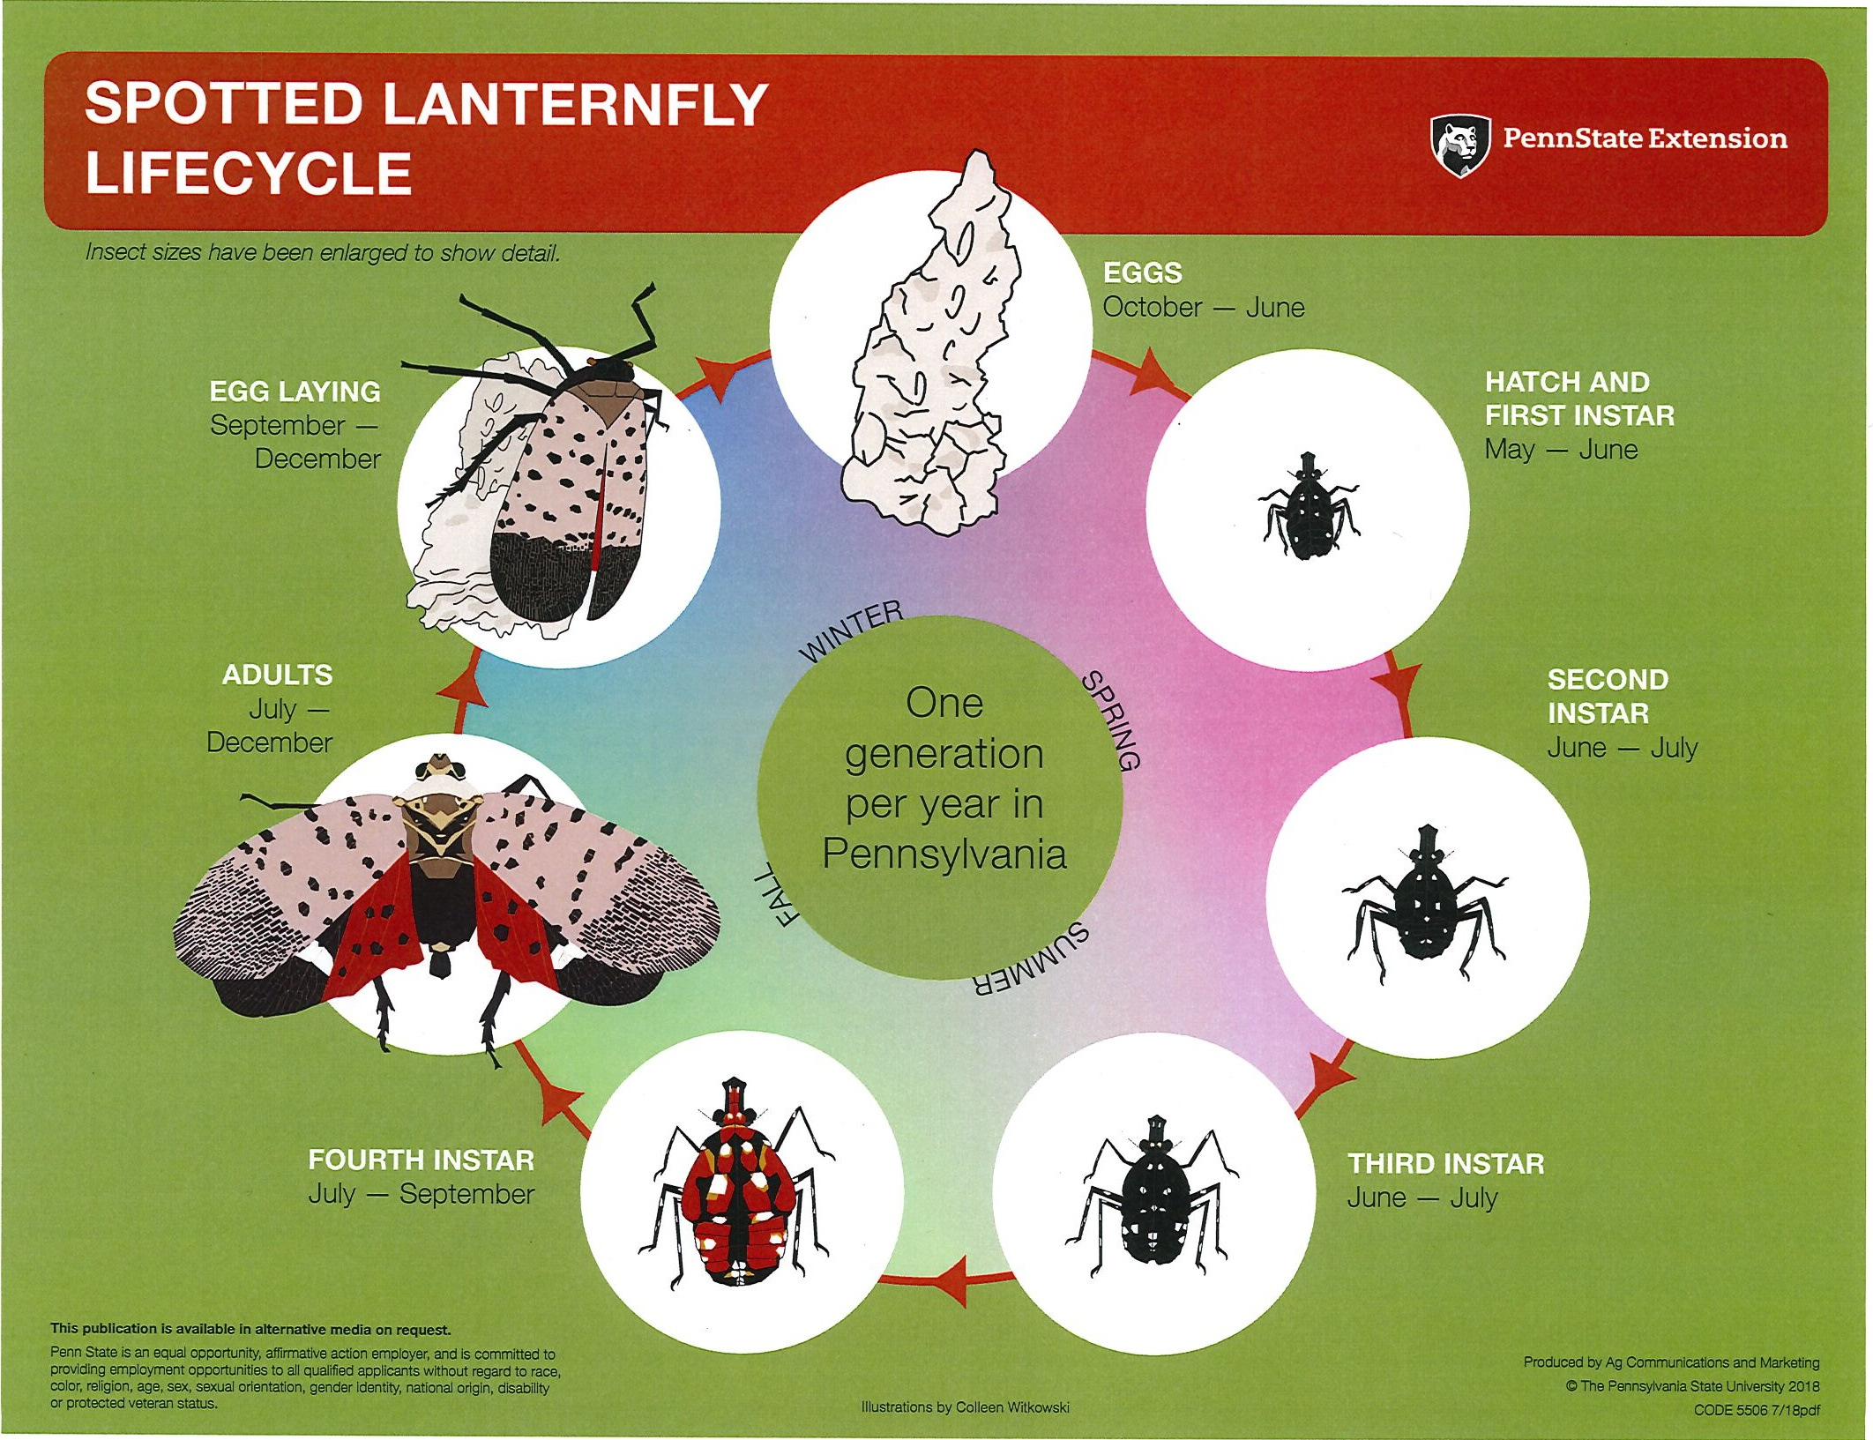
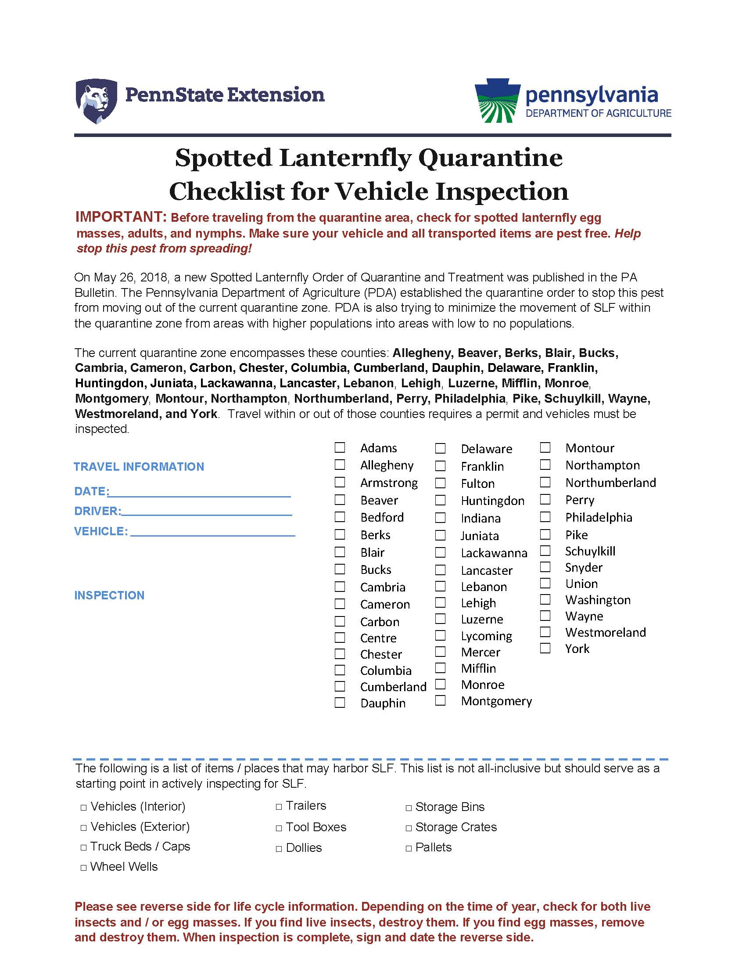

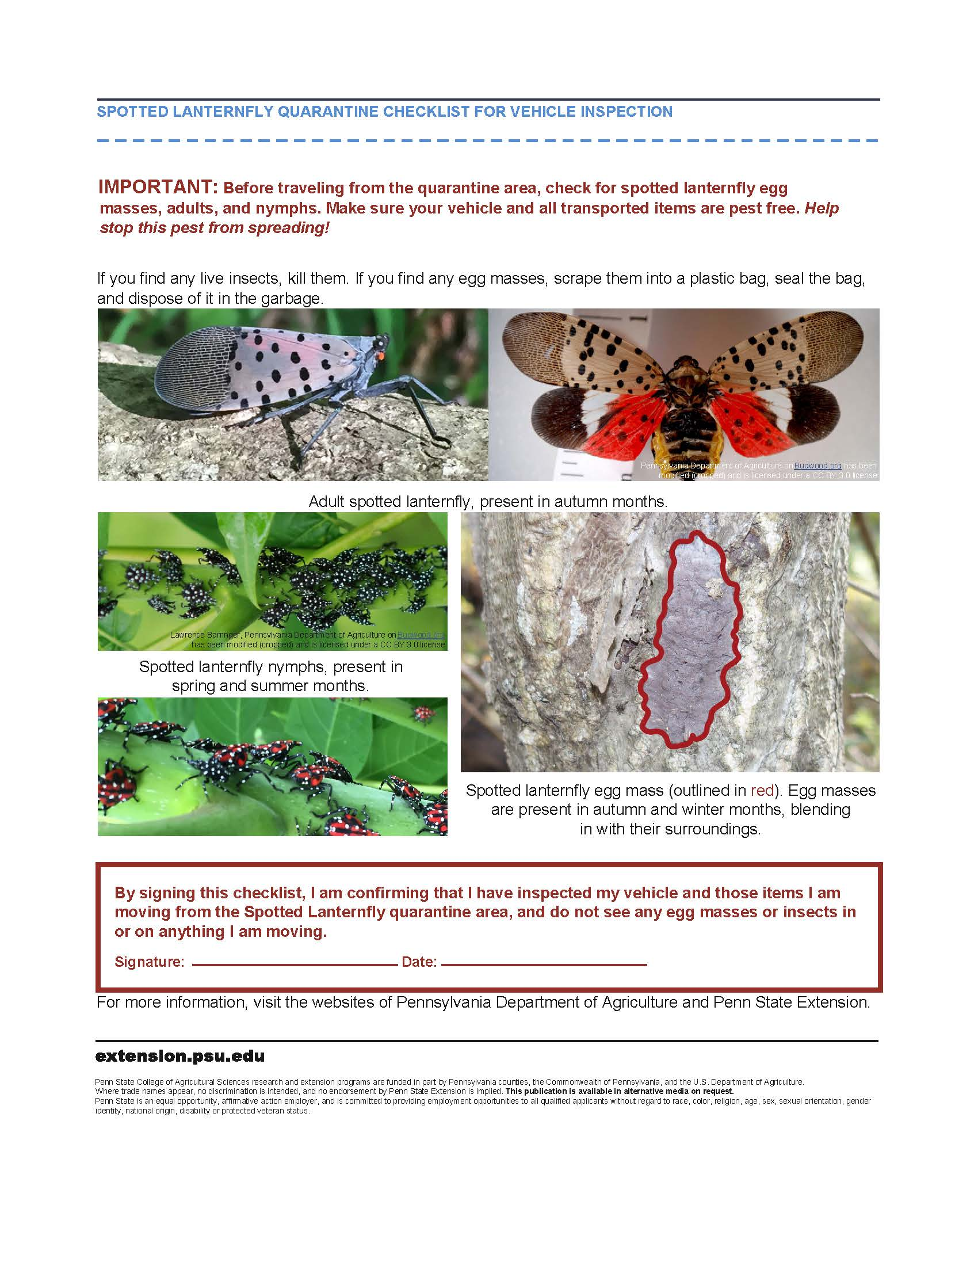

Spotted Lanternfly Vehicle Report
VEHICLE ID: |  | LICENSE PLATE NO:
DATE | Travel within, into, or out of the Quarantine area? | DRIVER* | SLF INSPECTIONS
 |  |  | SLF - None | SLF - Found - Destroyed

*By signing, I certify that the information reported herein is accurate and true.
Spotted Lanternfly Designated Employee Self-Audit

SLF Designated Employee: Date:

Campus/College/Unit/Department:

Item | Yes/No/NA | Comments
- Has the SLF Designated Employee completed the PDA training?
- Are there any vehicles under your purview that will not enter the Quarantine Zone? If yes, please describe.
- Do you have employees in your area that use their own vehicles for business?
- Do all vehicles that may enter the Quarantine Zone have permits?
- Have you reviewed the Quarantine Zone to determine if it has expanded?
- Do you have a process to determine if an employee who is planning to drive in the Quarantine Zone has taken the required training?
- Do all your vehicles have SLF kits with plastic baggies, a stiff SLF card to scrape off egg masses, a SLF lifecycle infographic, and inspection forms?
- Do you have training certificates for everyone in your area who has completed the training?
- Do you have two years of records of inspections? Note in the comments when you began keeping records.

Other Comments/Clarifications:

Please complete this form by the end of December and submit a copy to the Campus Director of Business Services or the College/Unit Safety Officer and to EHS (6 Eisenhower Parking Deck or PSUEHS@psu.edu)

Revision Summary Table

Date | Revision Summary
5/2/2019 | Initial program document
8/15/2019 | Updated Penn State EHS email address
3/25/2021 | Updated document to reflect new Order of Quarantine and Treatment; added counties to document
3/29/2022 | Updated document to reflect Addendum to Order of Quarantine and Treatment; added counties to document

Note that these requirements do not apply to travel directly through the Quarantine Zone with no stops except for refueling or traffic control.

