Event Fire Safety Requirements

The following requirements must be met when University facilities are used for any PSU event, such as entertainment, conferences, lectures, displays, meetings, social gatherings, student-sponsored events, etc. The person responsible for the event must ensure these requirements are followed. All Penn State employees need to be aware of these requirements.

- Crowd / Event Manager is identified, onsite and responsible to ensure all safety requirements are met and maintained.
- The occupancy limit for the area being used is not exceeded. This number will change based on the room configuration and layout. (Contact EHS to determine the occupant loads for specific rooms.)
- Procedures must be in place to accurately monitor and control the number of permitted occupants.
- All aisles, passageways and corridors/hallways shall be clear of obstructions and provide a minimum 44” width. For use of large occupant load rooms such as gymnasiums, lecture halls, contact EHS.
- Tables and chairs may be placed in hallways as long as the required minimum clear width (44”) is maintained.
- All exit doors shall be unlocked and operable.
- All exit doors shall be maintained clear and unobstructed on both sides.
- Exit signs shall be visible, illuminated and unobstructed.
- Emergency lighting units shall be unobstructed.
- All fire protection equipment shall be operable, visible and accessible with a clearance of 36”. This includes fire extinguishers, fire alarm pull stations, fire alarm horns, bells, speakers/strobe devices, and smoke detectors.
- Temporary cords (electrical, video etc.) shall not cause a tripping hazard. If cords need to be placed in areas of travel, appropriate protective devices must be installed over the cords.
- Decorations used shall be made of non-combustible or fire-resistive materials.
- Tapestries, parachutes and other similar items shall not be suspended overhead.
- If tents or canopies are used, they shall be flame resistant or non-combustible. If labeling indicating this is not affixed to the tent, proper certifications shall be provided by the supplier.
- Vehicles / Trailers shall be parked in designated parking stalls so as not to block building exits or emergency vehicle access lanes.
- EHS approval is required for the use of any open flame device, pyrotechnics, or theatrical fog/haze machine(s).
- If the event requires the setup of temporary seating, the attached “Seating Set-up Guidelines” shall be followed.

Seating Set-up Guidelines

Temporary seating set-up shall comply with the following Guidelines and any local jurisdictional requirements. The total number of seats permitted in a room is based on the maximum room occupant load and exit availability. The following identifies different seating arrangements and required clearances.
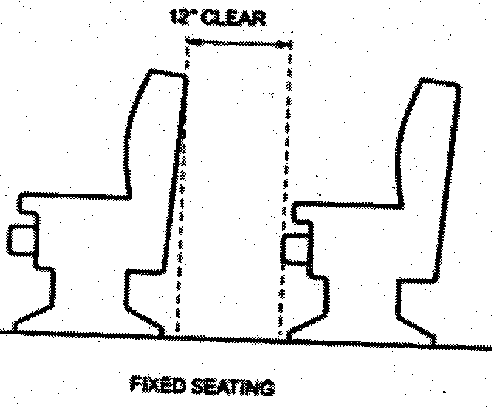

Minimum Seating Clearance
A minimum of 12 inches of clearance must be provided between
rows of seats. This minimum clearance requirement may increase
based on number of seats per row and the configuration of the seating rows.

Rows of seating served by an aisle or doorway at one end only.
- The minimum width of 12 inches clearance between rows shall be increased by 0.6 inch for
every additional seat beyond seven in a row, but the minimum clear width need not exceed 22
inches.
- The distance to the point where an occupant has a choice of two directions of travel to an exit
shall not exceed 30 feet from the point where the occupant is seated. Example: If a row of
seats is set up against a wall, the row cannot be greater than 30 feet long, and the row must
end in an aisle which has two directions of travel to an exit.

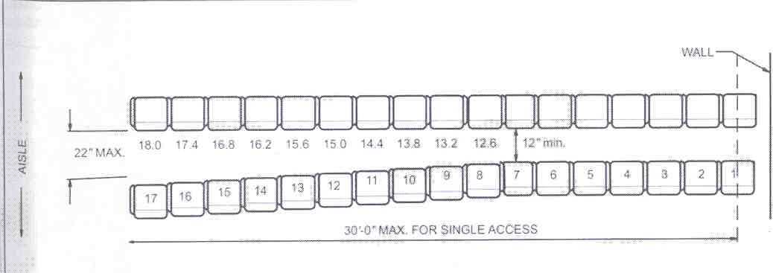
Single Access Seating Row

Rows of seating served by aisles or doorways at both ends.
- There may be no more than 100 seats per row.
- The minimum width of 12 inches clearance between rows shall be increased by .3 inch for
every additional seat beyond 14 in a row, but the minimum clear width need not exceed 22
inches.
Example:
If row is to have 54 or more seats there must be at least 22 inches between seating rows.

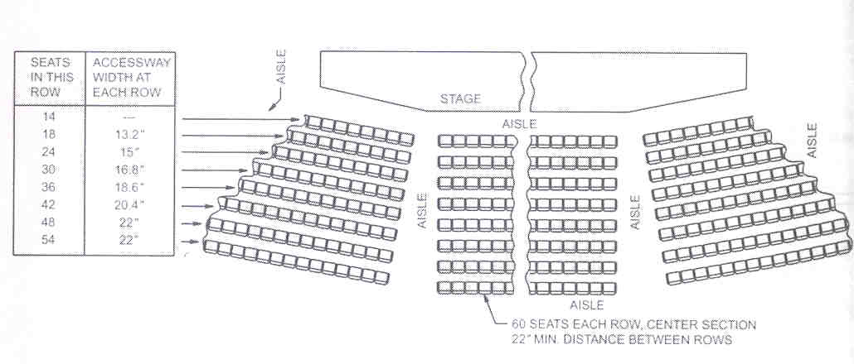

Required Aisle Widths
All aisles must lead to an exit and have a minimum clear width of:
Seating on one side – Minimum 36 inch aisle
Seating on both sides – Minimum 42 inch aisle
Aisle width determined by (.22”) x (Number of seats)
(250 Seats requires 55” center aisle)
(500 Seats requires 110” center aisle)

Seat Stability
Seats shall be fastened together in groups of not less than three if more than 200 seats are provided or seats shall be fastened to the floor. Seats which interlock together meet this requirement, otherwise alternate fastening methods must be used (i.e. plastic ties) to prevent seats from being moved.

Table and Chairs
A minimum clearance between adjoining tables and chairs must be maintained to allow unobstructed movement by occupants.

