**CHEMICAL WASTE MANAGEMENT PLAN**



Document# EHS-0026 Version 1.0

Date : January 4, 2021

**Table of Contents**

[1 Purpose 3](#_Toc58853959)

[2 Scope 3](#_Toc58853960)

[2.1 Applicability of Chemical Waste Management Plan 3](#_Toc58853961)

[3 Responsibility 3](#_Toc58853962)

[4 Definitions 4](#_Toc58853963)

[5 Chemical Waste Management Plan 5](#_Toc58853964)

[5.1 Hazardous Waste Determination 5](#_Toc58853965)

[5.1.1 Existing Waste Streams 5](#_Toc58853966)

[5.1.2 New Waste Streams 5](#_Toc58853967)

[5.2 Container Labeling and Management 5](#_Toc58853968)

[5.2.1 Waste Tag 6](#_Toc58853969)

[5.2.2 Additional Information 6](#_Toc58853970)

[5.2.3 Labeling Unused or Expired Products 7](#_Toc58853971)

[5.2.4 Management of Containers 7](#_Toc58853972)

[5.3 Waste Accumulation 8](#_Toc58853973)

[5.3.1 Satellite Accumulation Area Storage 8](#_Toc58853974)

[5.3.2 Weekly Satellite Accumulation Area Inspection 8](#_Toc58853975)

[5.3.3 Satellite Accumulation Area Signage 9](#_Toc58853976)

[5.3.4 Quantity Limit 9](#_Toc58853977)

[5.4 Chemical Cleanouts 9](#_Toc58853978)

[5.5 Chemical Waste Disposal 9](#_Toc58853979)

[5.5.1 Chemical Waste Disposal at University Park 9](#_Toc58853980)

[5.5.2 Chemical Waste Disposal at Non-University Park Locations 9](#_Toc58853981)

[5.6 Universal Waste Management 10](#_Toc58853982)

[5.7 Waste Oil 10](#_Toc58853983)

[5.7.3 Waste Oil Disposal 11](#_Toc58853984)

[5.8 Waste Glycol 11](#_Toc58853985)

[5.8.3 Waste Glycol Disposal 12](#_Toc58853986)

[5.9 Auditing 12](#_Toc58853987)

[5.10 Training for Generators 12](#_Toc58853988)

[5.10.1 Training Availability 12](#_Toc58853989)

[5.11 Emergency Procedures 13](#_Toc58853990)

[5.12 Chemical Inventory 13](#_Toc58853991)

[5.13 Availability of Chemical Waste Management Plan 13](#_Toc58853992)

[Attachment A: Waste Labeling Guidance Document 14](#_Toc58853993)

[Attachment B: New Waste Stream Identification Form 16](#_Toc58853994)

[Attachment C: Satellite Accumulation Area sign 19](#_Toc58853995)

[Attachment D: SAA Weekly Inspection Form 21](#_Toc58853996)

[Attachment E: Chemical Waste Management Program Self-Audit 23](#_Toc58853997)

[Attachment F: Universal Waste – Lamp & Ballast Guide 26](#_Toc58853998)

[Attachment G: Universal Waste – Battery Guide 30](#_Toc58853999)

# Purpose

The purpose of this Chemical Waste Management Plan (CWMP) is to outline the requirements for the management and disposal of wastes generated in all non-academic areas at Pennsylvania State University that must be followed in accordance with the federal Resource Conservation and Recovery Act (RCRA). As a steward for environmental resources, Penn State adheres strictly to the regulations set forth by the Environmental Protection Agency (EPA) and Pennsylvania Department of Environmental Protection (PADEP). Penn State’s Environmental Health and Safety (EHS) department interprets and implements these regulations for the many different programs and operations on all of its campuses.

# Scope

## Applicability of Chemical Waste Management Plan

This Chemical Waste Management Plan has been developed in accordance with the requirements of RCRA (40 CFR 262). This plan covers groups generating waste from the Office of Physical Plant, Auxiliary and Business Services, Intercollegiate Athletics, University Police and Public Safety, Campus Maintenance Operations, and University Health Services, among others. The CWMP defines the management of all regulated chemical waste materials generated in areas covered under this plan within the premises of all Penn State locations.

The University’s lab and research areas and associated facilities follow the Laboratory Waste Management Plan to meet the requirements of the Academic Laboratories rule found in 40 CFR 262 Subpart K.

# Responsibility

Budget Executives and Budget Administrators – have the primary responsibility to maintain a safe work environment within their jurisdiction, by monitoring and exercising control over their assigned areas. They shallensure the requirements of this plan are met and that someone is designated to perform the responsibilities of this plan in all applicable areas under their control.

Generators – are responsible for following all aspects of this CWMP. They must provide information on wastes that are generated to EHS or their supervisor to ensure a proper waste determination can be performed. They are required to ensure their waste is disposed of properly as defined in this plan.

Supervisors – implement the CWMP within their area of control and ensure all generators follow the CWMP. They serve as liaison to EHS when more information is needed to safely pick up waste or complete the waste determination.

Trained Professionals/ Waste Vendors – are responsible to ensure waste is picked up from generating locations and transported properly to the Central Accumulation Area (CAA) or final disposal facility. They ensure all materials are packaged and labeled properly for off-site shipments. They can also assist in making and documenting hazardous waste determinations.

EHS – is responsible for managing the University’s chemical and hazardous waste program, including all areas covered under the CWMP. As trained professionals, EHS completes waste determinations on behalf of the waste generators and produces documentation of determinations. EHS periodically evaluates generators and the program for compliance and serves as the main point of contact for all regulatory inspections.

# Definitions

*Acutely Hazardous Waste* – a waste that is one of the acutely hazardous commercial chemical products listed in 40 CFR 261.33(e).

*Central Accumulation Area* (*CAA*) – a chemical waste accumulation area for waste amounts greater than 55 gallons. These areas operate under different requirements than SAA’s and must be approved by EHS.

*EHS Waste Management System* – web-based software managed by EHS that allows generators at University Park to submit requests for chemical waste disposal.

*Environmental Health and Safety (EHS)* – Penn State Environmental Health and Safety department

*Generator* – Any Penn State employee or student who in the course of their operations generates waste to be collected by EHS.

*Chemical Cleanout* – the removal of large quantities of chemicals and other materials that are no longer needed or that have expired, outside the course of a regularly scheduled removal of material. These must be approved by EHS.

*Satellite Accumulation Area (SAA)* - a location at or near any point of generation where chemical waste is initially accumulated in containers prior to removal by the waste vendor or trained professional.

*Trained Professional* – A person who has completed the applicable RCRA training requirements of 40 CFR 265.16 for large quantity generators or is knowledgeable about normal operations and emergencies in accordance with 40 CFR 262.34(d) (5) (iii) for small quantity generators and very small quantity generators. A trained professional may be an employee of the facility or may be a contractor or vendor who meets the requisite training requirements.

*Universal Waste -* is a type of waste with hazardous components that can be managed differently than hazardous waste when recycled. Universal waste is defined in 40 CFR 273.9, and includes rechargeable batteries and lamps.

*Waste* – any material that is no longer needed or used.

*Waste Determination* - the process used by the University to determine if a material should be collected and managed as a hazardous waste.

*Waste Vendor* – A RCRA trained professional contracted by Penn State to collect, manage, and dispose of the University’s wastes to meet all applicable regulatory standards.

*Working Container* – A small container used by a worker in the course of their work to collect waste.

# Chemical Waste Management Plan

## Hazardous Waste Determination

### Existing Waste Streams

Chemical wastes that are generated in areas covered under the CWMP are required to have a proper hazardous waste determination completed at the time of generation or one on record with EHS. This determination must be completed by EHS prior to the waste being generated and all documentation of the waste determination will be maintained by EHS. These determinations are provided as part of this Plan as the Waste Labeling Guidance Document (Attachment A).

### New Waste Streams

EHS must be contacted prior to waste being generated from material that does not have a waste determination completed. EHS will require the generator to fill out and return the New Waste Stream Identification Form (Attachment B) prior to waste generation.

## Container Labeling and Management

All waste containers must be labeled with an EHS waste tag (waste tag) at the point and time of generation, meaning as soon as the first volume of waste goes into the container. Penn State will consider all materials that are no longer wanted or used that are ready to be collected for disposal as waste and will refer to them as such. Penn State requires a completed EHS waste tag to be attached to all containers of wastes. **It is the responsibility of the generator to ensure all containers are properly labeled.**

To obtain more waste tags, please contact the EHS office at (814) 865-6391 or by using the “Contact Us” form on the EHS website at www.ehs.psu.edu. Waste tags can also be requested in the notes section of the EHS Waste Management System when requesting a waste pickup at University Park or from the Regional EHS Coordinator for Non-University Park locations.

The following figure illustrates the EHS waste tag areas required by this plan.

**Figure 1: EHS Waste Tag Front and Back**

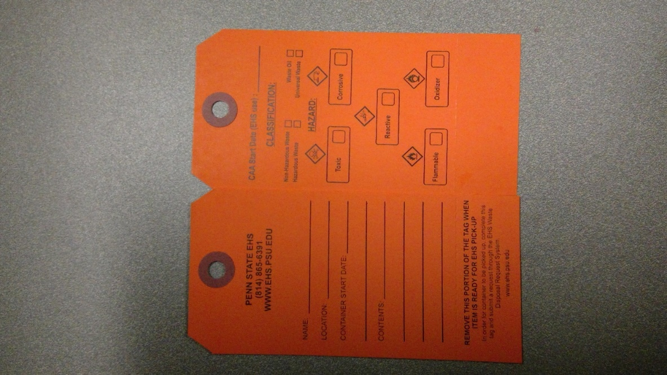

The back of the waste tag is to be used to meet EPA’s hazardous waste labeling requirements, including waste classification and hazard identification. EHS provides classification and hazard information in the Waste Labeling Guidance Document (Attachment A), and the generator is responsible for filling out the tag at the start of accumulation.

### Waste Tag

The generator is responsible for accurately labeling their waste. The generator must include their name, the location of the waste, including building name and room number, the container start date (the date the first volume of waste was added to the container), and the contents of the container. If unable to fit the contents onto one tag, please attach an additional tag or paper that continues listing the remainder of the contents. These contents must be accurate as they are an indication of the hazard of the material in the container.

The generator must also fill in the waste determination information on the back of the tag. Using the Waste Labeling Guidance Document (Attachment A), the generator must fill out the correct classification and hazard for their waste. Instructions to fill out the tag are as follows:

*FRONT:*

**Name**: Fill out the name of the primary person generating the waste.

**Location:** Include building name and room number at minimum. If there is specific additional location information, i.e., flammable cabinet, garage bay, etc., please include that information in this section.

**Container Start Date:** The date the first volume of waste was added to the container.

**Contents:** The chemical composition of all of the waste in the container. This should include percent composition for mixtures. If all of the information regarding the chemical contents cannot fit onto the EHS waste label, it should be included on an additional tag or attachment, and on the EHS waste pickup request form so the information is associated with the waste container.

**“Remove this portion of the tag when item is ready for EHS Pick-up”:** When a pickup request has been submitted into the EHS Waste Management System or to the Regional EHS Coordinator, please remove the tear-off portion of the tag so it is clear to the waste vendor or trained professional which containers need to be removed from the SAA.

*BACK:*

**CAA Start Date:** This line is for EHS use only.

**Classification:** Check the box for the appropriate waste classification.

**Hazard:** Check the pictogram(s) that describes the hazard associated with your waste.

### Additional Information

Any additional information that may not fit onto the waste label must be attached to the tag using an additional tag or attachment and must be included in the waste pickup request submitted into the EHS Waste Management System or provided to the Regional EHS Coordinator. This includes any additional notes on the contents of the container.

### Labeling Unused or Expired Products

A waste tag must be used on all waste materials, including expired and unused product, unless generated during an EHS approved chemical cleanout. Due to the large volume of waste received, EHS requires confirmation from the generator that the material in the container is the same as that listed on the original label – the waste tag provides this confirmation.

### Management of Containers

#### Condition of Containers and Working Containers

Waste must only be stored in compatible containers that are in good condition. Good condition includes, but is not limited to, no excess rust, no dents, and no waste on the outside of container. The generator must ensure that all containers in the SAA are closed properly, not leaking, and being stored in/on proper containment and in a location that protects the integrity of the container (i.e., from freezing temperatures). Any leaking containers must be replaced immediately, and the container must be disposed of properly. Working containers must be closed at all times unless waste is being added or removed, except when venting is allowed by regulation and pre-approved by EHS.

#### Secondary Containment

Secondary containment is required for the storage of all wastes. Secondary containment is necessary to reduce and prevent leaks or spills, mixing of incompatible substances, and damage to materials. Secondary containment should be able to handle 110% of the volume of the largest container it holds. Waste containers shall be segregated into different secondary containment based on chemical compatibility (contact EHS for guidance as necessary). Any spills inside secondary containment must be cleaned up immediately with all free material being removed from the containment. EHS can supply secondary containment for containers up to five gallons in size. It is the responsibility of the work unit to purchase larger containment; contact EHS for requirements.

#### Container Requirements

EHS can supply appropriate containers; **containers that do not meet these requirements will not be picked up and materials will need to be transferred to appropriate containers by the generator.**

All containers must meet the requirements outlined in 5.2.4.1. Closed means the container must have vapor tight seal; lids or bungs must be secured, or funnels must have a sealable lid. If a container that contained a hazardous material is to be reused or disposed, it must follow EHS’s chemical container recycling and disposal guidelines.

In addition, any outer container greater than five gallons in size of hazardous wastes must be stored in DOT approved drums and have a UN stamp on them. The UN stamp designates an internationally recognized performance standard and the accompanying numbers will vary based on the type (poly, metal) of container. Liquid wastes can only be stored in containers rated for liquids with all gaskets in place.

**Figure 2: Examples of UN Rating on Drum**

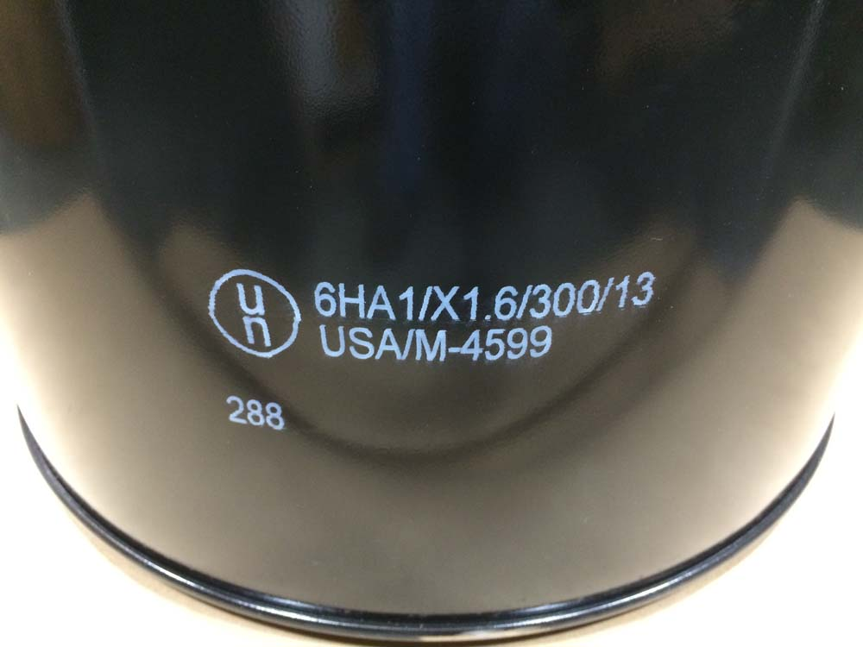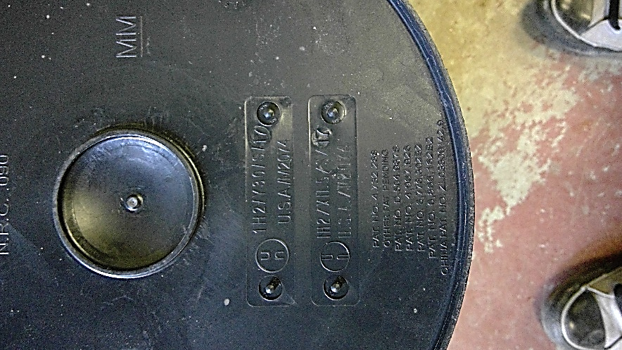

EHS can supply appropriate containers; **containers that do not meet these requirements will not be picked up and materials will need to be transferred to appropriate containers by the generator.**

## Waste Accumulation

### Satellite Accumulation Area Storage

All chemical waste must be stored in a designated Satellite Accumulation Area (SAA). This must be close to the point of waste generation and under the oversight of someone familiar with the waste. A backup monitor should be designated for the waste area. Wastes generated as part of remote maintenance or operations throughout the campus can be taken to the generator’s primary SAA for storage and disposal. The waste must be collected in a compatible container (in good condition) and tagged at the generating location prior to being moved. Wastes must be taken from the point of generation to the primary SAA by a University employee in a University vehicle, with the material being secured and inside secondary containment to prevent spills. No waste material is to be left in a vehicle after the end of a shift. If the waste is not moved to the primary SAA, then a separate SAA must be set up with all SAA requirements followed. For special projects, including but not limited to construction, demolition and renovations, or activities that produce large quantities of waste that are generated at a remote area, contact EHS for storage and disposal options prior to the start of the project or activity.

### Weekly Satellite Accumulation Area Inspection

Container condition, secondary containment, proper storage, and volume limits must be verified by the generator weekly using the SAA Weekly Inspection Form (Attachment D). Any discrepancies or issues must be addressed, corrected immediately, and documented on the form. These forms must be kept for three years in your Chemical Waste Management Plan binder.

### Satellite Accumulation Area Signage

A Satellite Accumulation Area Sign (Attachment C) must be posted in the vicinity of the SAA. This sign contains information on storage and spill response requirements. Sign templates can also be downloaded from the EHS website.

### Quantity Limit

Should the volume of waste in a SAA exceed 55 gallons of hazardous waste and/or one (1) quart of acutely hazardous waste (list is on the EHS website), the waste must be removed from the SAA within three (3) calendar days of the date that the limit was met. Generators must mark the corresponding date that the quantity limit was exceeded on the container’s waste tag and notify EHS immediately at 814-865-6391 or through your Regional EHS Coordinator. If you regularly generate greater than 55 gallons of waste at one location, contact EHS to set up a CAA for the location.

The generator is expected to monitor this accumulation quantity limit through their SAA weekly inspection formand notify EHS when the waste is within 10 gallons of reaching the quantity limit.

## Chemical Cleanouts

Cleanouts are done periodically as necessitated by building closure, building renovations, etc., and must be coordinated with EHS personnel. Certain cleanouts may require notification to EPA, which EHS will perform. The area is responsible for providing a full chemical inventory for the cleanout to be submitted through the EHS Cleanout Tracking Form (contact EHS for form). Only EHS pre-approved cleanouts can be submitted through the tracking form in place of using the standard waste management process. EHS will evaluate the inventory and determine the schedule for removal of the wastes.

## Chemical Waste Disposal

All chemical waste disposal must be through an approved EHS waste vendor and coordinated by EHS. A review of the chemical inventory at each location is required at least annually and any old, unneeded, and expired chemicals should be disposed of when no longer useful.

### Chemical Waste Disposal at University Park

EHS picks up material on a regular schedule from areas on campus, which gives work units many opportunities to submit their waste for removal before reaching a quantity limit. This regular pickup schedule is available on the EHS website. Submit a chemical waste pickup request using the EHS Waste Management System which can be accessed from the waste disposal page of the EHS website. EHS will arrange for the pickup of waste- **No waste can be dropped off at EHS’s CAA without prior scheduling from EHS.** All waste must have a completed waste request submitted and be properly labeled and packaged in order to be accepted by EHS. Waste without a properly completed waste tag, without a torn off lower portion, or not meeting the container requirements in sections 5.2.4.1 and 5.2.4.3 will not be picked up.

### Chemical Waste Disposal at Non-University Park Locations

Waste will be picked up according to regulatory requirements and the quantity of waste requiring disposal at each location. EHS should be contacted in advance when large quantities of waste will be generated from one event - at least two weeks’ notice is needed for drum quantities of waste. Coordination of waste pickups will be through EHS. Complete a Non-University Park Chemical Waste Request Form and submit to EHS either through your Regional EHS Coordinator or the Hazardous Materials Program Manager**. Only Penn State employees who have completed the appropriate training may sign hazardous waste shipping papers** (see Section 5.10 of this plan for requirements).

## Universal Waste Management

Universal wastes are commonly generated though out the University which have regulatory requirements for storage and disposal.

For handling, storage, and disposal requirements for batteries follow the Universal Waste Battery Guide in Attachment G. For handling, storage, and disposal requirements for lamps and ballasts follow the Universal Waste Lamp and Ballast Guide in Attachment F. If your area only handles universal waste you are only required to follow the battery and/ or lamp and ballast guide, you are not required to follow the SAA requirements. **Only Penn State employees who have completed appropriate training may sign universal waste shipping papers** (see Section 5.10 of this plan for requirements).

## Waste Oil

Oil that is required to be disposed of, is known as waste oil in the state of Pennsylvania. Depending on how the oil has been used, it will be classified as hazardous or non-hazardous waste. Non-hazardous waste oil can be recycled for beneficial use, which supports Penn State’s sustainability initiatives. Therefore, it is important to keep hazardous substances out of oil whenever possible. All oil, whether hazardous or non-hazardous, must be disposed/recycled through EHS.

#### 5.7.1 Materials Prohibited in Waste Oil

If any of the prohibited materials listed below have been added to the waste oil it can no longer be recycled, and it must be submitted to EHS as chemical waste. The labeling of the oil container must identify the contaminants so it is clear that this waste oil cannot be recycled (e.g., waste oil with refrigerant or waste oil with chlorinated solvents).

If you add prohibited materials into the waste oil and it is picked up by our waste vendor, it will contaminate the entire tanker load of oil. **The unit responsible for the contamination will be responsible for the extra cost.**

Prohibited materials include but are not limited to:

* Gasoline
* Chlorinated solvents (brake cleaner)
* PCB Oil
* Parts washer solvents
* Water-based coolants
* Glycol (antifreeze)
* Cooking oils
* Refrigerant oil
* Gas/oil mixtures
* Avgas
* Jet Fuel
* Cutting fluid

#### 5.7.2 Waste Oil Storage Requirements:

Store waste oil in a tank, drum, or other container in good condition (not leaking). The container may be either plastic or metal. All containers must have secondary containment or be double walled. Label the container with an orange waste tag or waste oil label following the Waste Labeling Guidance document (Attachment A); list "Waste Oil” or “Waste Oil Only” in the contents section. The container must be kept closed except when in use. Do not allow a filter to drain into an open waste container for more than a few minutes. Some funnels are equipped with lids that allow for a filter to be placed inside it; these are acceptable as long as the lid is kept closed and secured. Maintain a written log to document all amounts and types of oil added to the container. Limit access to the container so that only allowable materials (see list above) are added to the waste oil container. Do not allow waste oil that is generated from non-Penn State locations, such as employees’ homes, to be added to the container. Ensure there is sufficient capacity remaining in the container before adding oil.

### Waste Oil Disposal

Only EHS-approved vendors can be used for waste oil disposal. Waste oil cannot be given to facilities that use it as fuel in small on-site waste oil burners. When the waste oil container is approaching capacity, University Park generators should submit a waste disposal request; certain pre-approved bulk accumulation areas can contact an approved vendor directly. Non-University Park locations should contact their Regional EHS Coordinator or the Hazardous Materials Program Manager. **Only Penn State employees who have completed appropriate training may sign waste oil shipping papers** (see Section 5.10 of this plan for requirements).

## Waste Glycol

Glycol solutions (ethylene and propylene) are potentially polluting materials and are required to be disposed of properly. Depending on how the waste glycol has been used, it will be classified as hazardous or non-hazardous waste. Non-RCRA/Non-DOT waste glycol does not apply to the 55 gallons storage limit restriction; however, all glycol should be handled and stored responsibly. It is important to keep hazardous substances out of waste glycol whenever possible. All waste glycol, whether hazardous or non-hazardous, must be disposed/recycled through EHS.

5.8.1 Materials Prohibited in Waste Glycol

If any of the prohibited materials listed below have been added to the waste glycol it can no longer be recycled, and it must be submitted to EHS as chemical waste. The labeling of the glycol container must identify the contaminants so it is clear that this waste glycol cannot be recycled (e.g., waste glycol with refrigerant or waste glycol with chlorinated solvents).

If you add prohibited materials into the waste glycol it will contaminate the entire tanker load of glycol. **The unit responsible for the contamination will be responsible for the extra cost.**

Prohibited materials include but are not limited to:

* Gasoline
* Chlorinated solvents (brake cleaner)
* PCB Oil
* Parts washer solvents
* Water-based coolants
* Oil
* Cooking oils
* Refrigerant oil
* Gas/oil mixtures
* Avgas
* Jet Fuel
* Cutting fluid

#### 5.8.2 Waste Glycol Storage Requirements:

Store waste glycol in a drum or other container in good condition (i.e., not leaking). The container may be either plastic or metal. All containers must have secondary containment. Label the container with an orange waste tag following the Waste Labeling Guidance document (Attachment A); list "Waste Glycol” and the type and percent of glycol (if known) in the contents section. The container must be kept closed except when in use. Limit access to the container so that only allowable materials (see list above) are added to the waste container. Ensure there is sufficient capacity remaining in the container before adding waste.

### Waste Glycol Disposal

Only EHS-approved vendors can be used for waste glycol disposal. Waste glycol cannot be drained disposed without written approval from local wastewater treatment plant. When the waste glycol container is approaching capacity, University Park generators should submit a waste disposal request. Non-University Park locations should contact their Regional EHS Coordinator or the Hazardous Materials Program Manager. **Only Penn State employees who have completed appropriate training may sign waste glycol shipping papers** (see Section 5.10 of this plan for requirements).

## Auditing

Assessing on-going compliance is an important component of any program and EHS periodically evaluates compliance against the CWMP requirements. In addition, supervisors are required to annually complete the Chemical Waste Management Program Self-Audit (Attachment E). A copy of the completed Self-Audit must be submitted to EHS in January of each year. The form can be emailed to [psuehs@psu.edu](mailto:psuehs@psu.edu) and a hard copy maintained in the area’s CWMP binder.

## Training for Generators

All generators and supervisors of waste generators, who generate chemical and universal waste must complete training. Generators must comprehend the training and be able to apply it to the scope of their work.

### Training Availability

Chemical Waste Management Training (Initial) must be completed at time of hire. Refresher training must be completed annually for those who continue working in positions that generate chemical and universal waste. These trainings are completed online and tracked through the University’s Learning Management System. Training records must be kept in the area’s CWMP binder.

Shipping training must be completed by anyone that will be signing shipping papers (hazardous waste, universal waste, and/or waste oil and glycol). This training is completed online and tracked through the University’s Learning Management system and must be completed every three years. Training records must be kept in the area’s CWMP.

## Emergency Procedures

Penn State has developed an Environmental Hazards Emergency Response Plan (EHERP) to address the storage, inspection, and spill/release response for hazardous materials, hazardous waste, and fuels/oil. The purpose of the EHERP is to describe measures implemented by the University to prevent spills and releases from occurring and to prepare for an effective, safe, and timely response to mitigate the impacts of a spill/release. A portion of the EHERP (Part II) contains a chapter for each facility that meets the threshold requirements and contains more specific detailed information on that location, materials stored, discharge scenarios, and countermeasures.

EPA requires that Large Quantity Generators have these plans at each location that generates hazardous waste. The University Park Campus is a Large Quantity Generator, and thus each Satellite Accumulation Area must have a chapter of the plan. Work areas are required to maintain a hard copy of their EHERP site specific information. Generators must be aware of the location of the plan.

At all other locations, the requirement for a plan chapter is based on storing oils and hazardous materials above certain thresholds. Satellite Accumulation Areas at these locations may or may not have a chapter of the plan.

At all locations, there is a designated Emergency Coordinator (and backup(s)) who can be contacted in the event of a significant spill or release where assistance may be needed to properly cleanup the release. The Emergency Coordinator can be contacted through University Police and Public Safety or the facility business office. In addition to spills and releases, the Emergency Coordinator should be contacted for other incidents that may impact the facility or the environment including fires and explosions.

## Chemical Inventory

University Safety Policy SY39 - Hazardous Chemical Inventory Management requires that all work areas maintain a chemical inventory in the Chemical Inventory Management System (CHIMS).

Regular use and required annual updates of the chemical inventory are an essential part of Penn State's efforts to comply with various regulations (e.g., Department of Homeland Security, Uniform Fire/Building Code, Emergency Planning and Community Right-to-Know, etc.) as well as to provide critical information to emergency responders entering an area where hazardous chemicals are present.

Work areas are also required to maintain a hard copy of their CHIMS chemical inventory in their CWMP binder.

## Availability of Chemical Waste Management Plan

This plan is available to generators, staff, and faculty, and any others at the University as requested. The plan is posted on the EHS website and updated with revisions as needed.

Attachment A: Waste Labeling Guidance Document



**Waste Labeling Guidance**

**Front of Tag**

Complete Name, Location, Container Start Date and Contents

**Back of Tag**

Use the chart below to complete the back of the waste tag

If the waste is not on the chart contact your supervisor or EHS

|  |  |  |  |
| --- | --- | --- | --- |
| **Waste Name** | **Classification to Check** | **Hazard to Check** | **Generated at this Location (Yes/No)** |
| Aerosol | Hazardous Waste | Flammable |  |
| Oil Based Paint | Hazardous Waste | Flammable |  |
| Latex Paint | Non-Hazardous Waste | None |  |
| Muriatic Acid (Kleen Strip) | Hazardous Waste | Corrosive |  |
| Used Oil | Waste Oil | None |  |
| Lead Acid Battery | Universal Waste | Corrosive |  |
| Propane Cylinder | Hazardous Waste | Flammable |  |
| Corrosive Cleaner | Hazardous Waste | Corrosive |  |
| Glycol Solutions  (ethylene or propylene) | Non-Hazardous Waste | None |  |
| Oil Spill Clean Up | Non-Hazardous Waste | None |  |
| Pesticides | Hazardous | Toxic |  |
|  |  |  |  |
|  |  |  |  |
|  |  |  |  |
|  |  |  |  |

The Classification of the material is determined by its environmental hazard, which is distinguished by the EPA.

The Hazard of the material is determined by its characteristics, which are usually distinguished by an SDS or analysis

Attachment B: New Waste Stream Identification Form

| **New Waste Stream Identification Form** | | | |
| --- | --- | --- | --- |
| **Generator Name:** | |  | |
| **Generation Location:** | |  | |
| **Waste Name:** | |  | |
| **Waste Compositions:**  *Using specific chemical names and/or descriptions of waste compositions, list all constituents present in the waste stream. Attach all safety data sheets (SDS) and all available analyses. If additional space is needed, attach additional sheets.* | | | |
| **Constituents** *Using specific chemical names (not chemical formulas) and/or descriptions of waste types, list all constituents present in the waste stream. Do not use trade names.* | **Range**  *For each constituent, indicate the approximate concentration. The total of the maximum values of the components must be equal or greater than 100%* | | **Units**  *Use any standard units such as percent (%), milligrams per liter (mg/l), milligrams per kilogram (mg/kg), parts per million (ppm), etc.* |
|  |  | |  |
|  |  | |  |
|  |  | |  |
|  |  | |  |
|  |  | |  |
|  |  | |  |
|  |  | |  |
|  | | | |
| **Process Generation** *Select a process from the list below that mostly accurately represents how the waste stream was generated. If you cannot find a process that accurately describes your generation process, select other and provide a description* | | | |
| **Process:** | | **Place an X in the column to choose which process represents your waste.** | |
| Expired material | |  | |
| Unused Material | |  | |
| Change out of equipment | |  | |
| Construction cleanup | |  | |
| Cleaning/Rinsing Waste | |  | |
| Analytical Processes | |  | |
| Spent Solutions | |  | |
| Cleanup of spills | |  | |
| Other, *please describe* | |  | |
|  | |  | |
| **Physical State:** | | **Place an X in the column to choose which physical state represents your waste.** | |
| Solid | |  | |
| Liquid | |  | |
| Sludge | |  | |
| Semi-Solid | |  | |
| Powder | |  | |
| Gas | |  | |
|  | |  | |
| **pH range** (*if applicable)*: | |  | |
|  | |  | |
| **Have the containers been stored outside?** | | | |
| Yes  (if yes, describe conditions of containers) | |  | |
| No: | |  | |
|  | |  | |
| Does this waste have any undisclosed hazards or prior incidents associated with it, which could affect the way it should be handled (e.g., burnt in a fire, etc.) | |  | |
|  | |  | |
| Additional Comments | |  | |

Jan. 2021

Attachment C: Satellite Accumulation Area sign

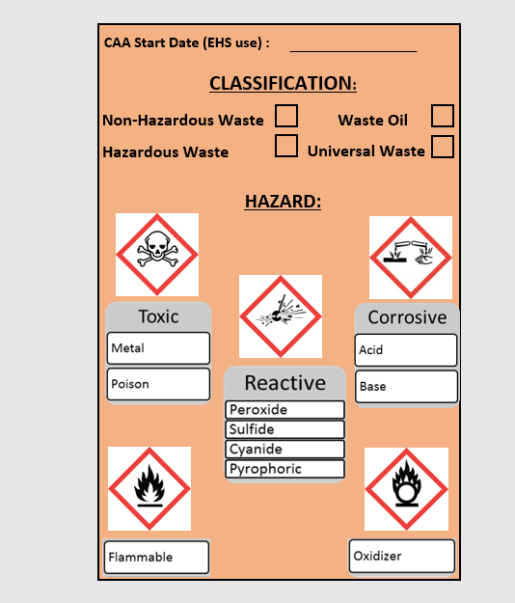

Chemical Spills in the SAA:

**STOP** the source of the spill

**CONTAIN** the spill

**CLEAN** up all small spills immediately using absorbent materials or universal spill pads

**CONTACT** EHS if replacement containers or secondary containment are needed or to report a sizeable spill

Major Spills:

**EHS:** (814) 865-6391 (M-F 8-5)

**University Police:** (814) 863-1111

Use the Waste Guidance Document to complete the waste determination on back of tag. **This must be done at the start of waste generation.**

If your item is not included on this chart, contact EHS at   
(814) 865-6391.

**SPILLS**

**WASTE TAG**

The satellite accumulation area must be inspected weekly. Containers must be labeled with a completed orange waste tag, including the waste determination section on the back of the tag.

The total volume of all hazardous waste containers in the SAA should never exceed 55 gallons.

Submit a waste request online at [www.ehs.psu.edu](http://www.ehs.psu.edu) to have waste removed from the SAA.

Containers must be closed, with the exceptions of adding, removing, or venting waste. Containers must be in good condition and stored in secondary containment.

**CONTAINER INFO**

**SATELLITE ACCUMULATION AREA**

**LOCATION: \_\_\_\_\_\_\_\_\_\_\_\_\_\_\_\_\_\_\_\_\_\_\_\_\_\_\_\_\_\_\_\_\_\_\_\_\_\_\_\_\_\_\_\_\_\_\_\_\_\_\_\_\_\_**

**RESPONSIBLE PERSON: \_\_\_\_\_\_\_\_\_\_\_\_\_\_\_\_\_\_\_\_\_\_\_\_\_\_\_\_\_\_\_\_\_\_\_\_\_\_\_\_\_\_\_\_\_**

**CONTACT NUMBER: \_\_\_\_\_\_\_\_\_\_\_\_\_\_\_\_\_\_\_\_\_\_\_\_\_\_\_\_\_\_\_\_\_\_\_\_\_\_\_\_\_\_\_\_\_\_\_\_**

Attachment D: SAA Weekly Inspection Form

|  |  |  |  |  |  |  |  |  |
| --- | --- | --- | --- | --- | --- | --- | --- | --- |
| **Satellite Accumulation Area Weekly Inspection**  **Supervisor Name:\_\_\_\_\_\_\_\_\_\_\_\_\_\_\_\_\_\_\_\_\_\_\_\_\_\_\_\_\_\_\_\_**  **Location (Building, Room #): \_\_\_\_\_\_\_\_\_\_\_\_\_\_\_\_\_\_\_\_\_\_\_** | | | | | | | | |
| **Date Checked** | **Labeled Properly** | **Segregated Properly** | **Not Leaking** | **Secondary Containment in Place** | **Containers Closed** | **New waste streams generated that require a determination?  Y/N** | **55 gallon storage limit for hazardous waste has not been exceeded** *(This waste must be submitted for EHS pickup)* | **Signature** |
|  |  |  |  |  |  |  |  |  |
|  |  |  |  |  |  |  |  |  |
|  |  |  |  |  |  |  |  |  |
|  |  |  |  |  |  |  |  |  |
|  |  |  |  |  |  |  |  |  |
|  |  |  |  |  |  |  |  |  |
|  |  |  |  |  |  |  |  |  |
|  |  |  |  |  |  |  |  |  |
|  |  |  |  |  |  |  |  |  |
|  |  |  |  |  |  |  |  |  |
|  |  |  |  |  |  |  |  |  |
|  |  |  |  |  |  |  |  |  |
|  |  |  |  |  |  |  |  |  |
|  |  |  |  |  |  |  |  |  |
|  |  |  |  |  |  |  |  |  |
|  |  |  |  |  |  |  |  |  |
|  |  |  |  |  |  |  |  |  |
|  |  |  |  |  |  |  |  |  |
|  |  |  |  |  |  |  |  |  |
|  |  |  |  |  |  |  |  |  |
|  |  |  |  |  |  |  |  |  |
|  |  |  |  |  |  |  |  |  |
|  |  |  |  |  |  |  |  |  |
|  |  |  |  |  |  |  |  |  |
|  |  |  |  |  |  |  |  |  |
|  |  |  |  |  |  |  |  |  |
|  |  |  |  |  |  |  |  |  |
|  |  |  |  |  |  |  |  |  |

Jan. 2021

Attachment E: Chemical Waste Management Program Self-Audit



**Chemical Waste Management Program**

**Annual Self-Audit Form**

*Submit completed self-audit to psuehs@psu.edu and to your department/ unit safety office. A copy must also be kept in the* Chemical Waste Management Plan binder

Supervisor: Date:

Inspector: Department/ Unit:

Building: Room number(s):

|  | **Yes** | **No** | **NA** |
| --- | --- | --- | --- |
| **A. TRAINING** | | | |
| 1. Have all personnel (including supervisor) completed Chemical Waste Management Training (initial) and placed certificates in the Chemical Waste Management Plan binder? |  |  |  |
| 1. Have all personnel (including supervisor) completed Chemical Waste Management Training (refresher) and placed certificates in the Chemical Waste Management Plan binder? |  |  |  |
| 1. Have all personnel who sign shipping papers completed RCRA/DOT training? |  |  |  |
| **B. SIGNS** | | | |
| 1. Is the Satellite Accumulation Area (SAA) sign posted at the waste storage area? |  |  |  |
| 1. Is the SAA sign information filled out? |  |  |  |
| 1. Is the Waste Labeling Guidance Document posted at the SAA? |  |  |  |
| **C. CHEMICAL AND HAZARDOUS WASTE** | | | |
| 1. Have waste generators read the Chemical Waste Management Plan? |  |  |  |
| 1. Do all waste containers have an orange tag attached, with the front (name, location, start date, and container contents) and back (classification and hazard) sections complete? |  |  |  |
| 1. Are SAAs inspected weekly and documentation maintained? Last inspected: \_\_\_\_\_\_\_\_\_\_\_\_\_ |  |  |  |
| 1. Is all waste stored in secondary containment? |  |  |  |
| 1. Is total volume of hazardous waste less than 55 gallons? |  |  |  |
| 1. Are all waste streams generated in area present on the Waste Labeling Guidance Document? |  |  |  |
| 1. Have all new waste streams had a waste determination completed by EHS? |  |  |  |
| 1. Has chemical inventory been updated within the last year in CHIMS? Last updated: \_\_\_\_\_\_\_\_\_ |  |  |  |
| **D. UNIVERSAL WASTE – BATTERIES AND LAMPS** | | | |
| 1. Are requirements of Battery Recycling Guide being followed (labeling, storage, disposal)? |  |  |  |
| 1. Are requirements of Lamp and Ballast Recycling Guide being followed (labeling, storage, disposal)? |  |  |  |
| **E. WASTE OIL/GLYCOL** | | | |
| 1. Has all waste been placed in closed and leakproof chemical grade containers? |  |  |  |
| 1. Have all waste containers been labeled properly? |  |  |  |
| 1. Have no prohibited materials (gasoline, brake cleaners, refrigerant oil, etc.) been added to your waste containers? |  |  |  |
| **F. FIRE EXTINGUISHERS** | | | |
| 1. Are extinguishers in designated locations and are these locations labeled? |  |  |  |
| 1. Are extinguishers accessible and free from obstructions? |  |  |  |
| 1. Is the current year and date of last inspection indicated on the tag? Date: \_\_\_\_\_\_\_\_\_\_\_\_\_ |  |  |  |

|  |  |  |  |
| --- | --- | --- | --- |
| **G. SAFETY SHOWERS AND EYEWASHES** | | | |
| 1. Are showers and eyewashes labeled, accessible, and free from obstructions? |  |  |  |
| 1. Are eyewashes and drench hoses flushed weekly? Last tested: \_\_\_\_\_\_\_\_\_\_\_\_\_ |  |  |  |
| 1. Is the current year and date of last EHS inspection indicated on the tag? Date: \_\_\_\_\_\_\_\_\_\_\_\_\_ |  |  |  |
| **H. FIRST AID** | | | |
| 1. Are first aid supplies kept in accordance with Penn State Policy SY21? |  |  |  |

Answering ‘NO’ to any question identifies an area that may require corrective actions.

**Please review the Waste Labeling Guidance Document at your SAA to determine the types of hazardous waste generated at this location and associated hazards and list below:**

|  |  |  |
| --- | --- | --- |
| Waste Generated at this location? (Yes/No) | Type of Hazardous Waste | Hazards |
|  | Flammable waste | Ignitable/fire |
|  | Corrosive waste | Human health - skin and eye irritants |
|  | Reactive waste | Heat generation, human health – skin and eye irritants |
|  | Oxidizer waste | Heat generation, human health – skin and eye irritants |
|  | Toxic waste | Human health – acute/chronic effects, adverse environmental effects to fauna/flora |

\_\_\_\_\_\_\_\_\_\_\_\_\_\_\_\_\_\_\_\_\_\_\_\_\_\_\_\_\_\_\_\_\_\_ \_\_\_\_\_\_\_\_\_\_\_\_\_\_\_\_\_\_\_\_\_\_\_\_\_\_\_\_\_\_\_\_\_\_ \_\_\_\_\_\_\_\_\_\_\_\_\_\_

Name of Supervisor (print) Signature of Supervisor Date

\_\_\_\_\_\_\_\_\_\_\_\_\_\_\_\_\_\_\_\_\_\_\_\_\_\_\_\_\_\_\_\_\_\_ \_\_\_\_\_\_\_\_\_\_\_\_\_\_\_\_\_\_\_\_\_\_\_\_\_\_\_\_\_\_\_\_\_\_ \_\_\_\_\_\_\_\_\_\_\_\_\_\_

Name of Department/Unit Safety Officer (print) Signature of Department/ Unit Safety Officer Date

Jan. 2021

Attachment F: Universal Waste – Lamp & Ballast Guide

|  |
| --- |
| **Environmental Health and Safety S:\EHS Protocols and Metrics\EHS Forms\OPP_EHS stacked positive - logo.png** |
| Attachment F – Universal Waste Lamp and Ballast Guide  **Document #:** EHS-0026atf  **Issued:** 01/04/2021  **Version: 0** |

**1.0 Purpose**

The following guidance is intended to outline the proper handling, storage, and disposal of lamps and ballasts generated within the University. Strict adherence to these requirements enables Penn State to manage these waste streams under the Universal Waste regulations. Failure to follow these requirements would require the materials to be regulated as Hazardous Waste.

**2.0 Scope**

This guidance covers all recyclable lamps and ballasts generated by University operations. Recyclable lamps include fluorescent tubes (e.g., circular, 2 ft., 4 ft., 6 ft., 8 ft., etc.), compact fluorescent lamps (CFLs), sodium lamps, mercury vapor lamps, metal halide lamps, projector bulbs, and ultra-violet (UV) lamps.

Incandescent lamps are not covered by this guidance and should be disposed with the regular trash generated for the area.

**3.0 Responsibility**

Specific responsibilities are defined within the Chemical Waste Management Plan.

**4.0 Procedures**

The procedures for proper handling of lamps and ballast are divided into several key sections, including; Packaging, Labeling, Transporting, and Disposal. The associated information for each type of waste is summarized below.

**Lamps**

4.1 Packaging Lamps – when a lamp is removed from service, the lamp must be containerized immediately to prevent breakage. The primary containers that should be used for collecting lamps for disposal can include:

* Original packaging (cardboard box) if in good condition (e.g., no missing flaps, all packaging material removed, etc.) and can be closed, or
* EHS supplied bulb container (e.g., cardboard box, bucket, drum, etc.).

Independent of the type of container selected, the container must meet the following criteria:

* Closed when not adding lamps to the container
* Stored in a dry location and not exposed to the weather
* Lamps should not be taped together prior to placing in the container
* Different types of lamps should be in different collection containers

Never place a broken lamp in the standard lamp collection container – all broken lamps should be collected in a separate container.

4.2 Labeling Lamp Containers – once a container is being used to collect lamps, proper labeling is required to be placed on the container. All containers collecting lamps must contain the following information:

* “Universal Waste – Lamps”
* Type of lamps stored in the container
* Accumulation start date (date the first lamp was placed in the container)
* Generator name (individual placing lamp into container)
* Building name or storage location

EHS can provide a label template that can be used by specific groups to pre-print their own labels.

4.3 Transporting Full Lamp Containers – there should be a central accumulation point for full containers to be stored prior to shipping them off-site for proper disposal. For University Park, a standard waste pickup request form (Light Tubes and Ballasts) must be submitted for lamp disposal to move them to the accumulation location (EHS Webpage - Waste Disposal link: <https://ehs.psu.edu/waste-disposal>). For campus locations, please work with the appropriate site contacts in maintenance.

In certain situations, off-site disposal may be direct from the generator location with EHS approval. There are specific paperwork requirements for this type of activity and all shipments must be coordinated through EHS prior to generating the lamps.

**Note – EHS will not pickup or accept lamps that are not properly packaged or labeled. It is the responsibility of the group generating the lamps to verify that the containers are in proper condition for transportation.**

4.4 Lamp Disposal – Off-site shipment of lamps is regulated and must comply with the Universal Waste regulations. In addition to the labeling requirements noted in Section 4.2, it includes the use of proper shipping papers (Bill of Lading). These shipping papers must be prepared prior to shipment by the vendor or EHS and meet the following requirements:

* Must include DOT proper shipping name and number of containers & weights
* Only signed by trained individuals
* Copy of completed Bill of Lading must be forwarded to EHS

Arrangements for proper lamp disposal must be coordinated through EHS. To begin this process at University Park, pickup requests must be submitted through the standard waste pickup process (ref. 4.3). For campus locations, please contact your Regional EHS Coordinator for the disposal of Universal Waste Lamps.

The shipment of Universal Waste lamps is regulated by DOT; therefore, retention of these shipping papers must be kept on-site for three (3) years in accordance with DOT regulations.

Attachment G: Universal Waste – Battery Guide

|  |
| --- |
| **Environmental Health and Safety S:\EHS Protocols and Metrics\EHS Forms\OPP_EHS stacked positive - logo.png** |
| Attachment G –Battery Guide  **Document #:** EHS-0026atg  **Issued:** 01/04/2021  **Version: 0** |

**1.0 Purpose**

The following guidance is intended to outline the proper handling, storage, and disposal of batteries generated within the University. Strict adherence to these requirements enables Penn State to manage these waste streams under the Universal Waste regulations. Failure to follow these requirements would require the materials to be regulated as Hazardous Waste.

**2.0 Scope**

This guidance covers all recyclable batteries generated by University operations. Recyclable batteries include lead acid, nickel cadmium, nickel metal hydride, lithium ion, and lithium polymer (single use) batteries.

Alkaline batteries are not covered by this guidance and should be disposed with the regular trash generated for the area.

**3.0 Responsibility**

Specific responsibilities are defined within the Chemical Waste Management Plan.

**4.0 Procedures**

The procedures for proper handling of batteries are divided into several key sections, including; Packaging, Labeling, Transporting, and Disposal. The associated information for each type of waste is summarized below.

**Batteries**

4.1 Packaging Batteries – when a battery is removed from service, the battery must have the terminals protected to prevent short circuiting. The protection of the terminals can be done using any of the following methods:

* Taping of the terminals, use clear tape so as not to cover battery markings and information.
* Place individual battery into a clear plastic bag and seal.

If large quantities of batteries are being generated for disposal, a secondary container may be used to consolidate the individually packaged batteries into one accumulation area. Batteries accumulated in secondary containers must meet the following criteria:

* UN rated polyethylene drum (1H)
* Closed when not adding batteries to the container
* Stored in a dry location and not exposed to the weather
* Batteries should not be taped together prior to placing in the container
* Different types of batteries should be placed in different collection containers
* Accumulation date shall not exceed 1 year from the start

Never place a broken or damaged battery in the standard battery collection container – all broken and damaged batteries should be collected in a separate container.

4.2 Labeling Battery Containers – once a container is being used to collect batteries, proper labeling is required to be placed on the container. All containers collecting batteries must contain the following information:

* “Universal Waste – Batteries”
* Type of batteries stored in the container
* Accumulation start date (date the first battery was placed in the container)
* Generator name (individual placing battery into container)
* Building name or storage location

4.3 Transporting Full Battery Containers – there is a central accumulation point for full containers to be stored prior to shipping them off-site for proper disposal. For University Park, a standard waste pickup request form (Chemical Waste) must be submitted for battery disposal to move them to the accumulation location (EHS Webpage - Waste Disposal link: <https://ehs.psu.edu/waste-disposal>). For campus locations, please work with the appropriate site contacts in maintenance.

In certain situations, off-site disposal may be direct from the generator location with EHS pre-approval. There are specific paperwork requirements for this type of activity and all shipments must be coordinated through EHS.

**Note – EHS will not pickup or accept batteries that are not properly packaged or labeled. It is the responsibility of the group generating the batteries to verify that the containers are in proper condition for transportation.**

4.4 Battery Disposal – Off-site shipment of recyclable batteries is regulated and must comply with the Universal Waste regulations. In addition to the labeling requirement noted in Section 4.2, it includes the use of proper shipping papers (Bill of Lading). These shipping papers must be prepared prior to shipment by the vendor or EHS and meet the following requirements:

* Must include DOT proper shipping name and number of containers & weights
* Only signed by trained individuals
* Copy of completed Bill of Lading must be forwarded to EHS

Arrangements for proper battery disposal must be coordinated through EHS. To begin this process at University Park, pickup requests must be submitted through the standard waste pickup process (ref. 4.3). For campus locations, please contact your Regional EHS Coordinator for the disposal of Universal Waste batteries.

The shipment of Universal Waste batteries is regulated by DOT; therefore, retention of these shipping papers must be kept on-site for three (3) years in accordance with DOT regulations.