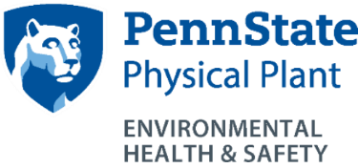
Snapshots!
Regulated Waste Management Program
http://ehs.psu.edu/infectious-waste-management/overview
EHS Contact: Beata Clapp, bqc5272@psu.edu
814-865-6391

Who does this program apply to?
- University employees, students, and visitors who generate or handle regulated medical waste in the performance of their duties.
- Examples of regulated medical waste include: needles, syringes, contaminated labware (petri dishes, culture tubes, pipettes, and tissue culture flasks), contaminated gloves, etc.
- Examples would include waste generated from nurses’ offices, microbiology laboratories, blood spill cleanups, items saturated with human blood, etc.

What are the key requirements of this program?
- Biohazard/infectious wastes should be placed into the appropriate containers (e.g. red/orange biohazard plastic bag, sharps container) and disposed through the campus specific regulated medical waste disposal vendor.
- Sharps containers must be rigid, leakproof, puncture resistant, and tightly lidded.
- While not truly regulated medical waste, preserved biological specimens (e.g. cats for dissection) should be disposed through the campus specific regulated medical waste disposal vendor.
- Regulated medical waste should be disposed of in accordance with the Penn State infectious waste disposal policy SY29.
- Supervisors must:
- Identify the individuals by job title(s) who handle regulated medical waste.
- Provide Personal Protection Equipment (PPE) and ensure that it is worn by employees.
- Ensure that regulated medical waste is disposed of properly and in a timely manner.
- Storage Requirements:
  - For less than 30 days: store at room temperature or in a refrigerator.
  - For less than 90 days: store in a freezer.
  - Sharps containers may be used until they are three-quarters full.
  - Waste that becomes putrescent (foul smelling) must be disposed of within 24 hours.
  - Autoclaving (steam sterilizing) will generally prevent waste from becoming putrescent.
- Recordkeeping Requirements:
  - Regulated medical waste manifest records must be received within 20 days of shipment.
  - Regulated medical waste manifest records must be maintained in a central location for 5 years from the date of shipment.

For additional information:
- Penn State Infectious Waste Disposal Policy SY29
https://policy.psu.edu/policies/sy29
- PA Department of Environmental Protection Infectious Waste Regulations
http://www.pacode.com/secure/data/025/chapter284/chap284toc.html

